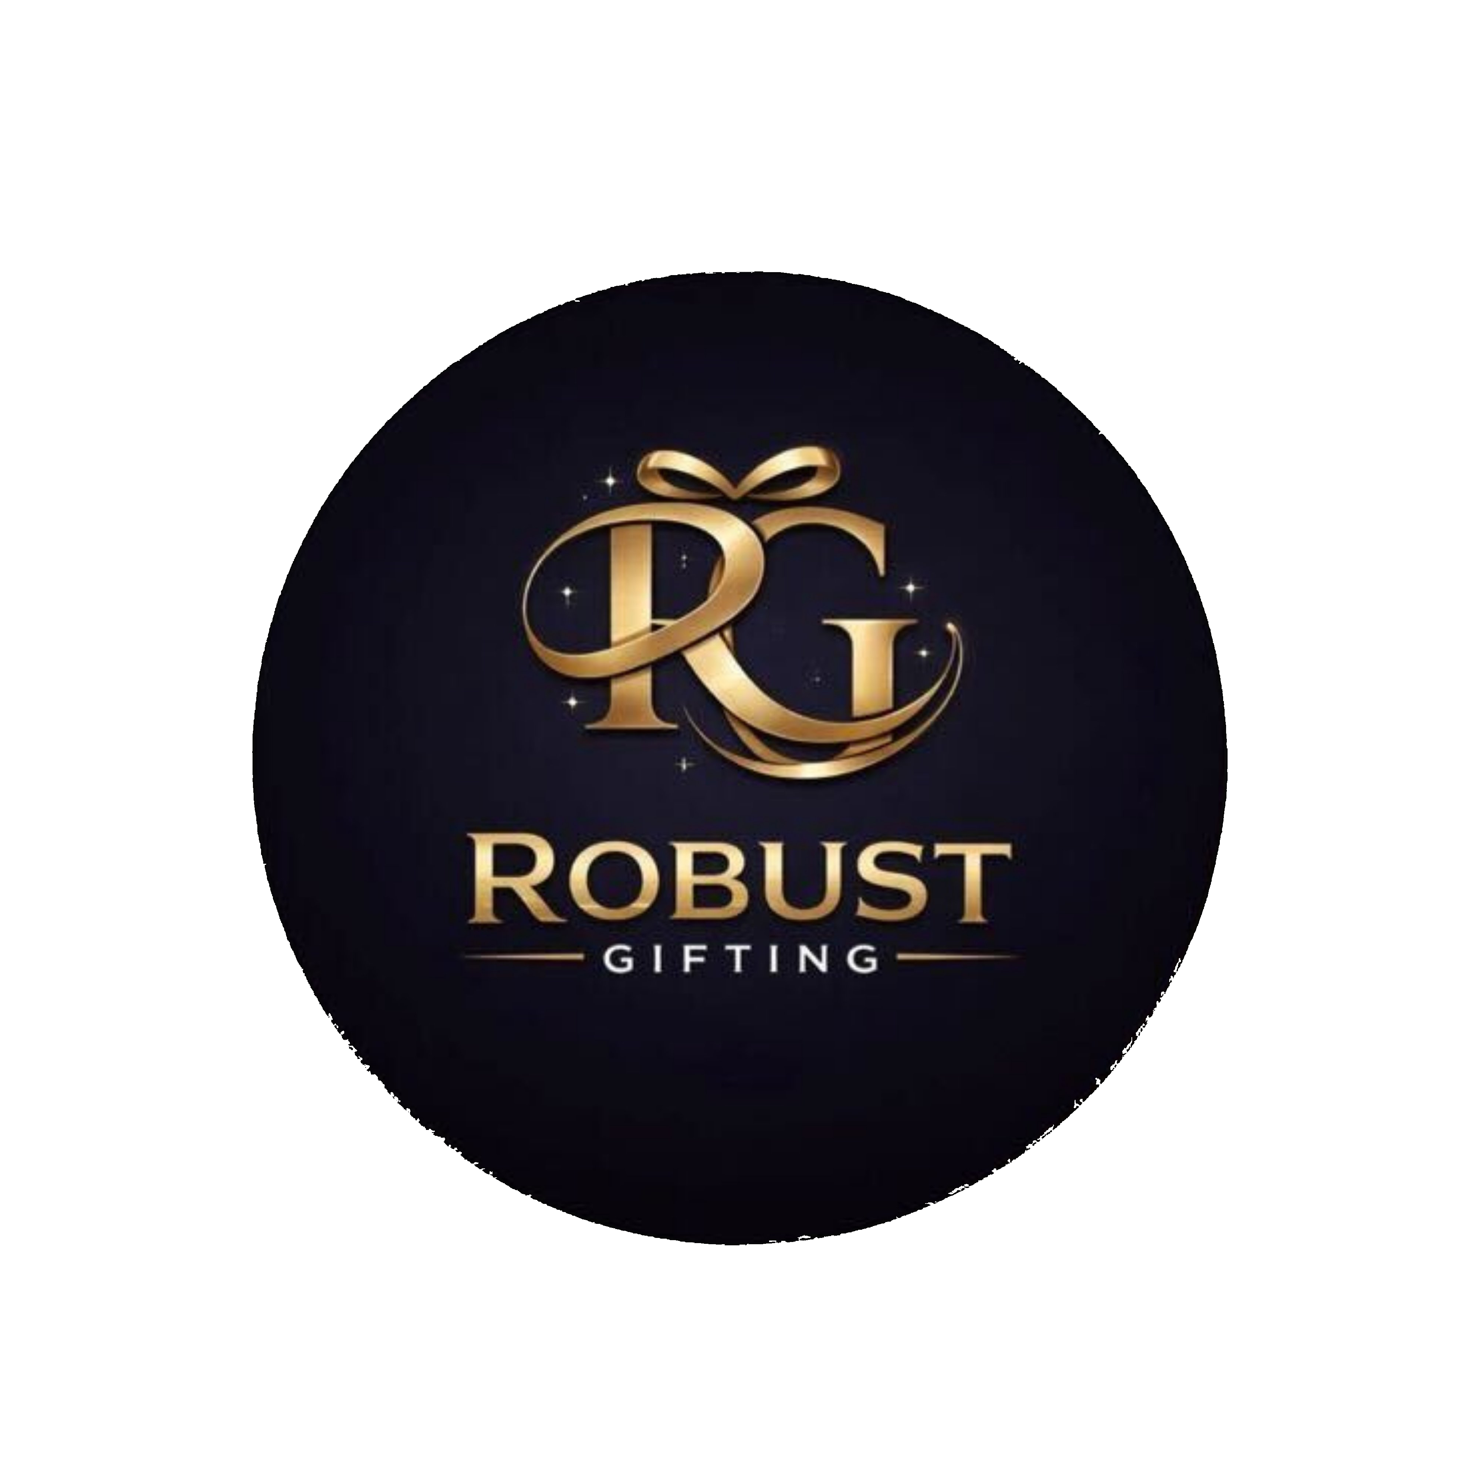
3-in-1 Combo Catalogue
Robust Gifting | Premium Corporate Gifting Solutions
50 Premium Designs | Prices exclusive of 18% GST
Diary, Pen & Bottle · Diary, Pen & Keychain · Bottle, Pen & Keychain

Item No. 01  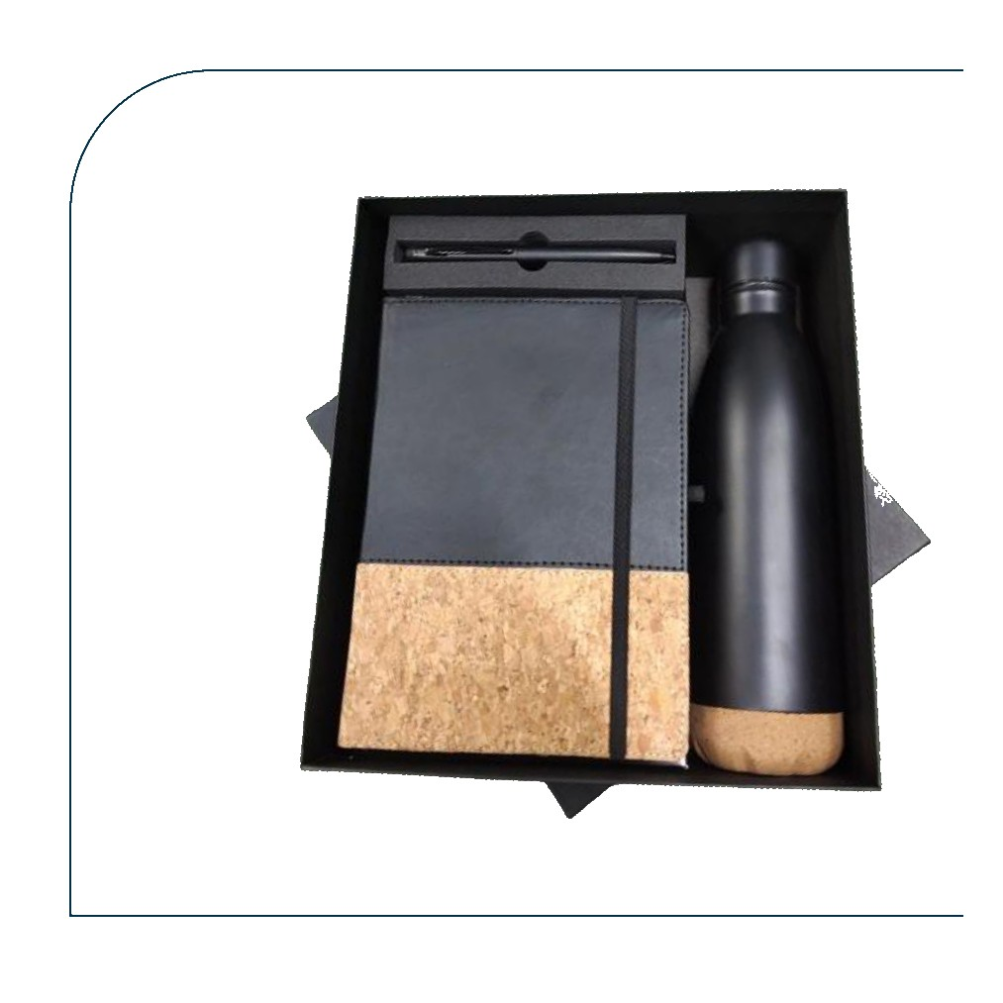  Black Diary + Metal Pen + Vacuum Bottle  Black leatherette diary with metal pen and matte black vacuum insulated cola bottle with cork base  Rs. 543/- Base Rs. 460 + 18% GST |  | Item No. 02  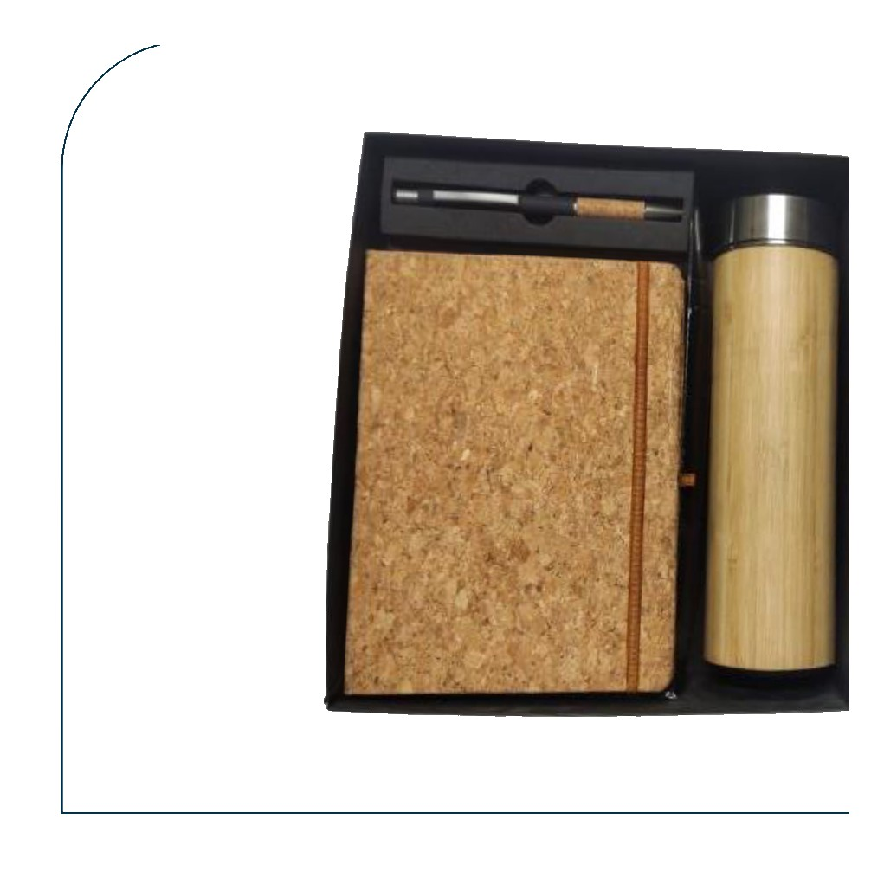  Cork Diary + Cork Pen + Bamboo Bottle  Full cork-cover diary with metal cork-grip pen and bamboo thermos bottle with steel lid  Rs. 519/- Base Rs. 440 + 18% GST
Item No. 03  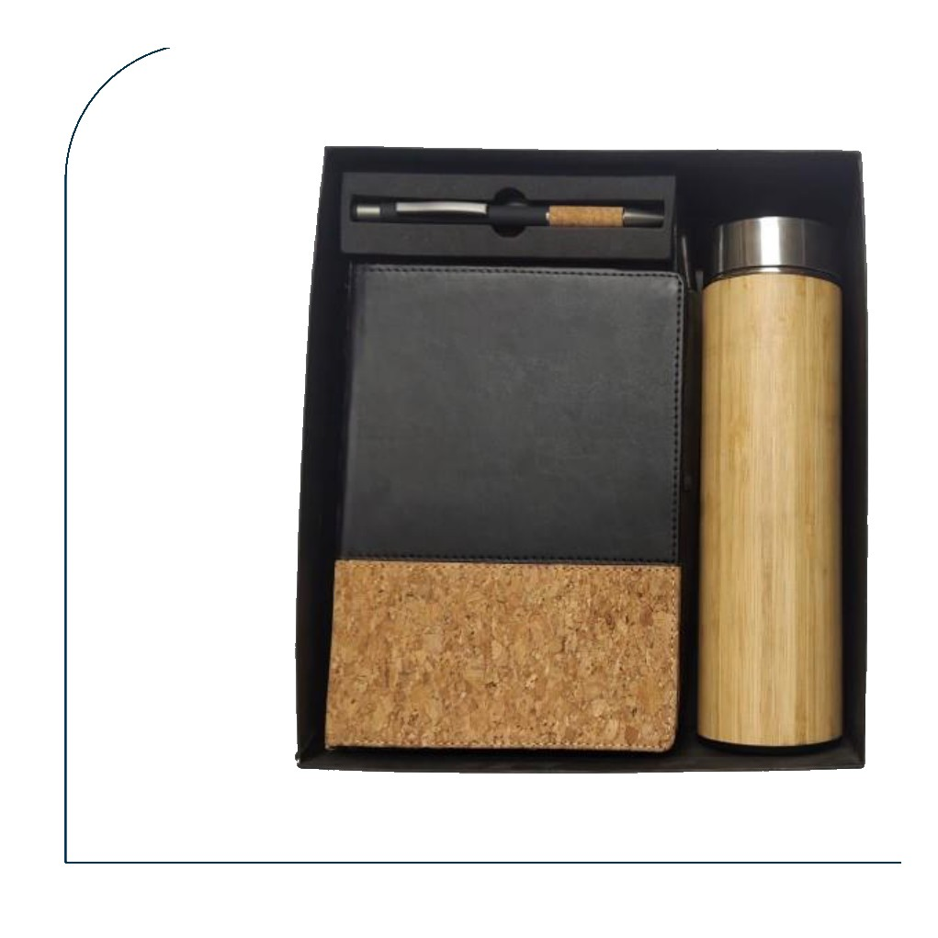  Black & Cork Diary + Cork Pen + Bamboo Bottle  Black & cork bi-material diary with metal cork-grip pen and bamboo insulated bottle  Rs. 519/- Base Rs. 440 + 18% GST |  | Item No. 04  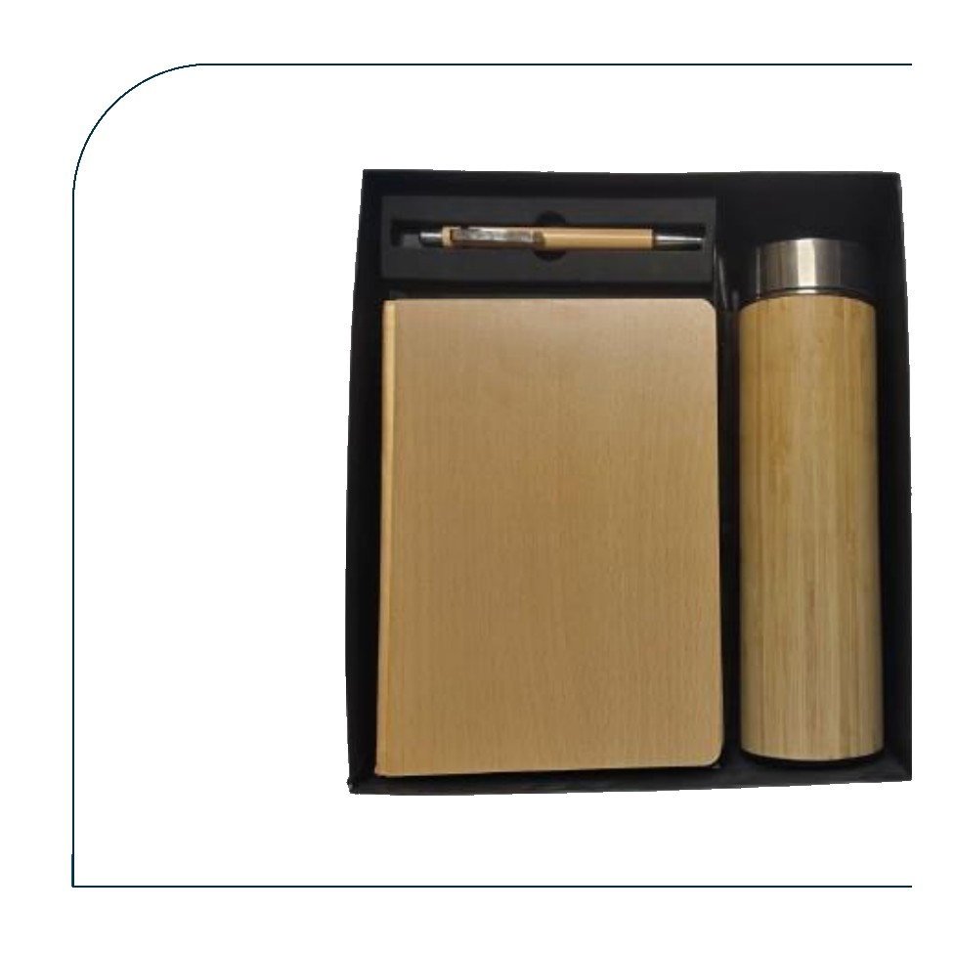  Bamboo Diary + Bamboo Pen + Bamboo Bottle  All-bamboo eco gift set — bamboo-cover diary, bamboo barrel pen and bamboo thermos bottle  Rs. 543/- Base Rs. 460 + 18% GST
Item No. 05  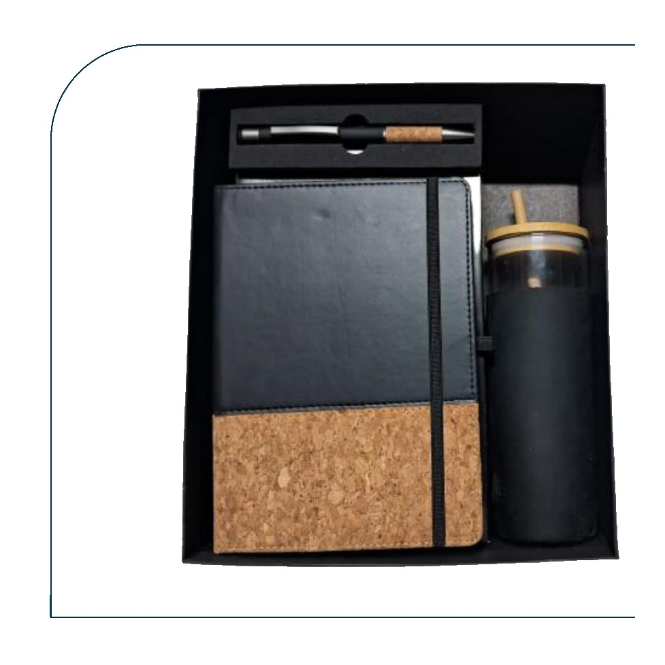  Cork Diary + Pen + Glass Bottle (Bamboo Lid)  Black & cork diary with ballpoint pen and clear glass bottle with bamboo screw lid  Rs. 401/- Base Rs. 340 + 18% GST |  | Item No. 06  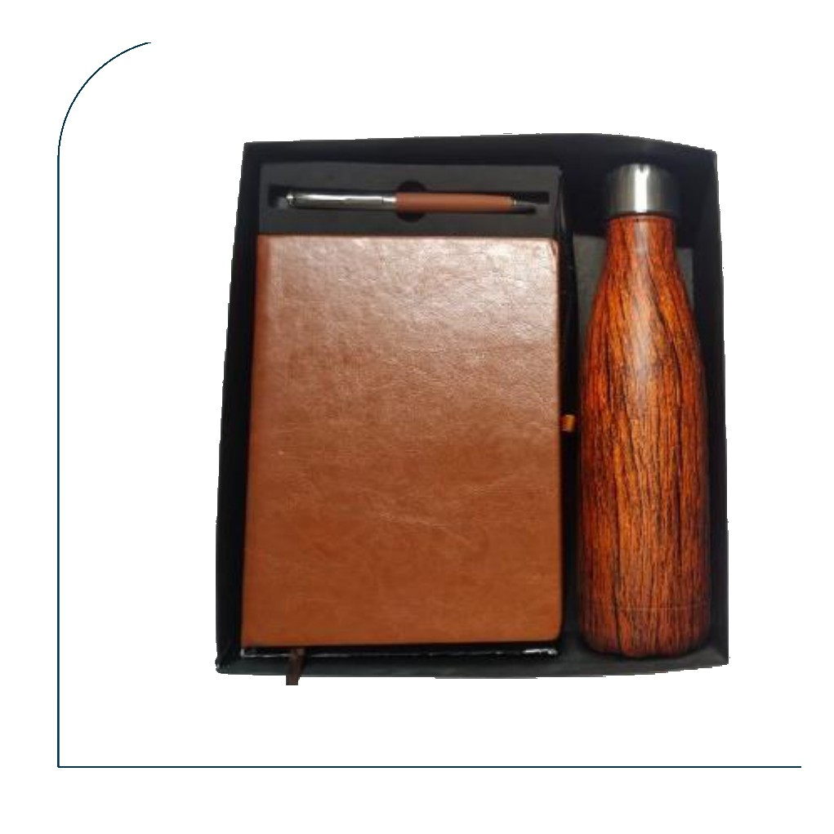  Tan Diary + Metal Pen + Bamboo Cola Bottle  Tan distressed leather diary with metal pen and wood-grain bamboo cola-shape bottle  Rs. 531/- Base Rs. 450 + 18% GST
Item No. 07  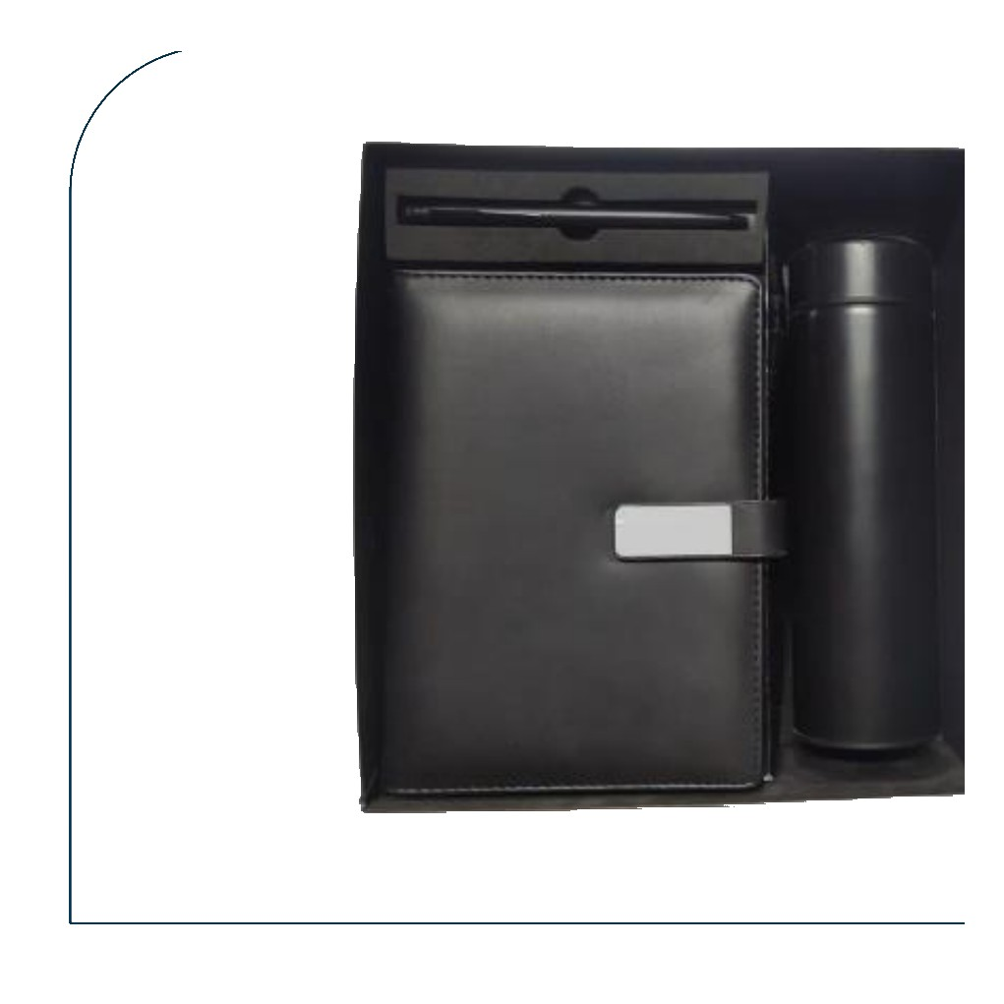  Black Diary + Pen + Temperature Bottle  Black leather clasp diary with pen and matte black smart temperature display bottle  Rs. 443/- Base Rs. 375 + 18% GST |  | Item No. 08  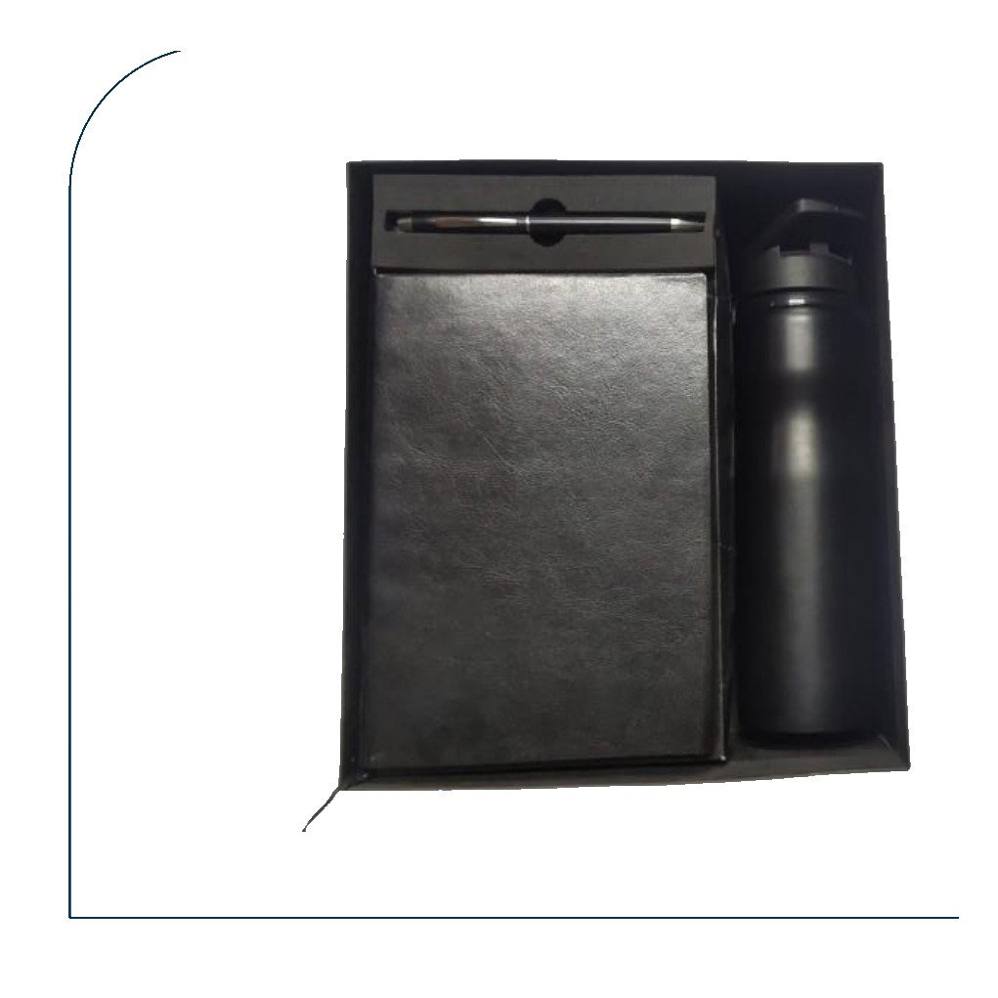  Black Diary + Pen + H2O Bottle 750 ml  Black glossy leather diary with pen and matte black H2O sports bottle 750 ml  Rs. 354/- Base Rs. 300 + 18% GST
Item No. 09  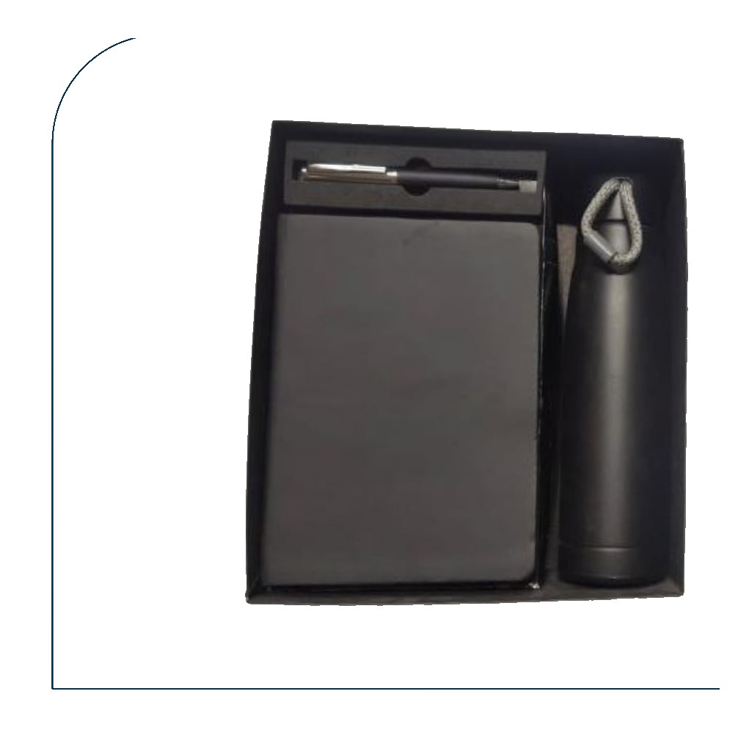  Grey Diary + Pen + Rope Bottle  Grey leatherette diary with pen and gunmetal slim bottle with rope carry handle  Rs. 419/- Base Rs. 355 + 18% GST |  | Item No. 10  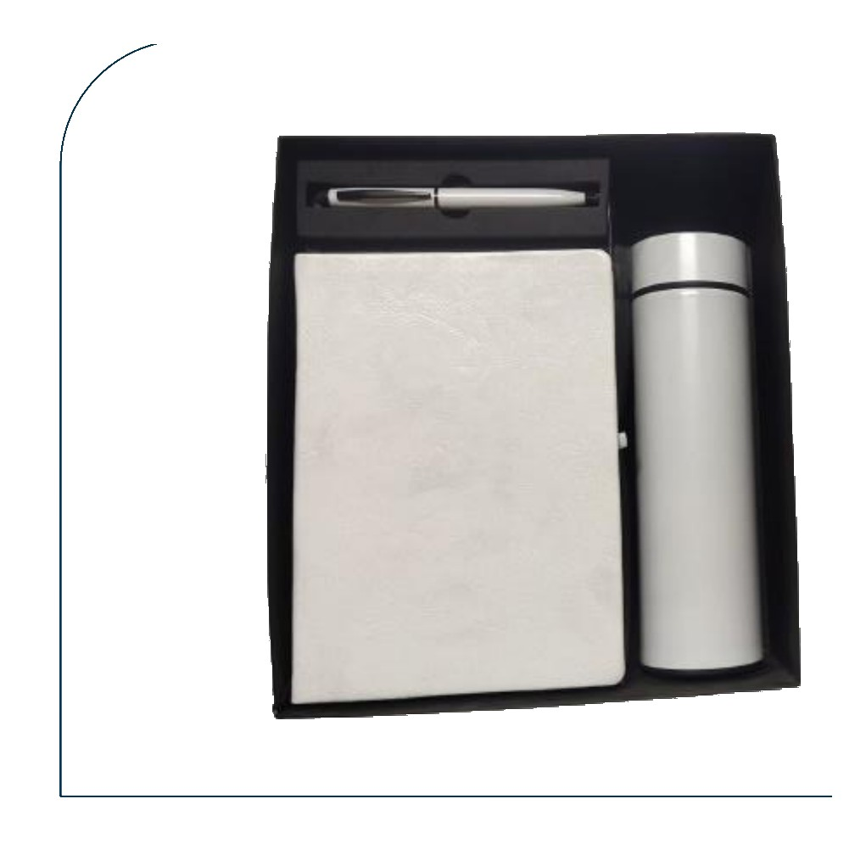  White Diary + Pen + Temperature Bottle  Pearl white leatherette diary with pen and silver smart temperature display bottle  Rs. 378/- Base Rs. 320 + 18% GST
Item No. 11  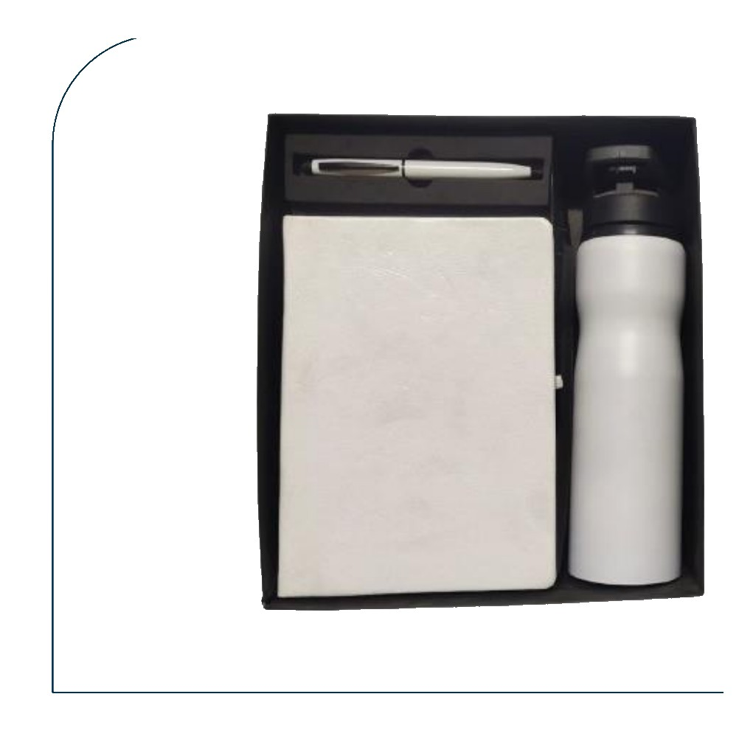  White Diary + Pen + H2O Bottle 750 ml  White leatherette diary with pen and white H2O sports bottle 750 ml  Rs. 354/- Base Rs. 300 + 18% GST |  | Item No. 12  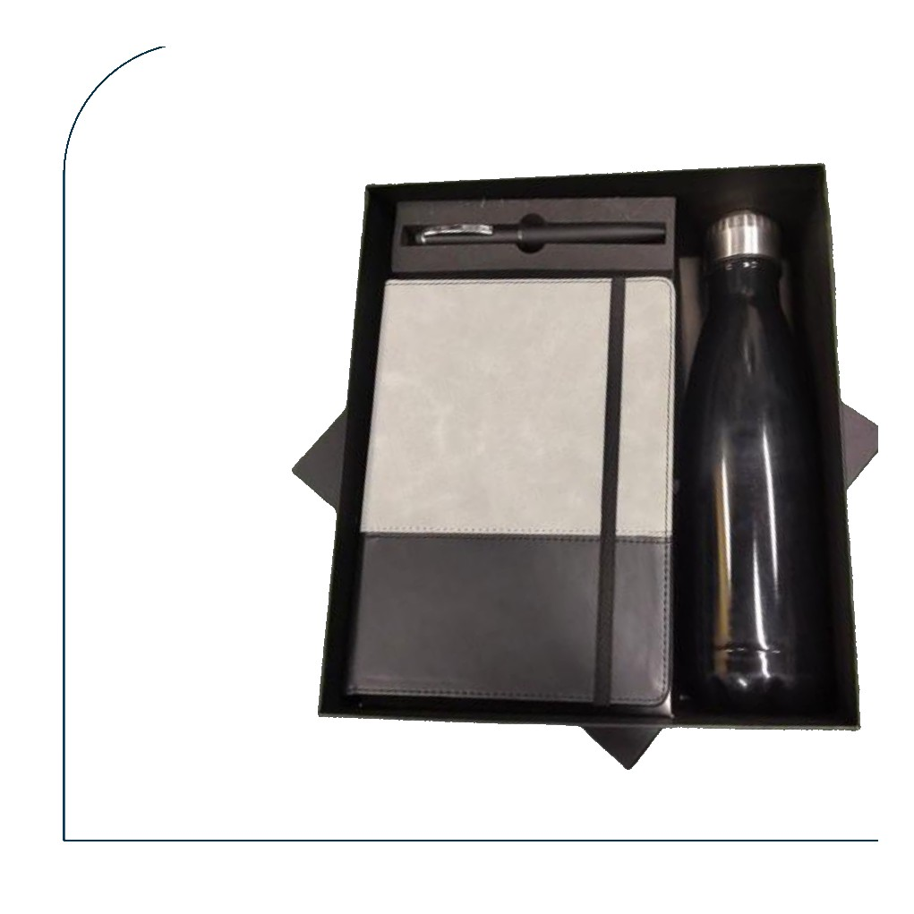  Grey Two-Tone Diary + Pen + Cola Bottle  Grey & dark two-tone leatherette diary with pen and black metallic cola bottle  Rs. 384/- Base Rs. 325 + 18% GST
Item No. 13  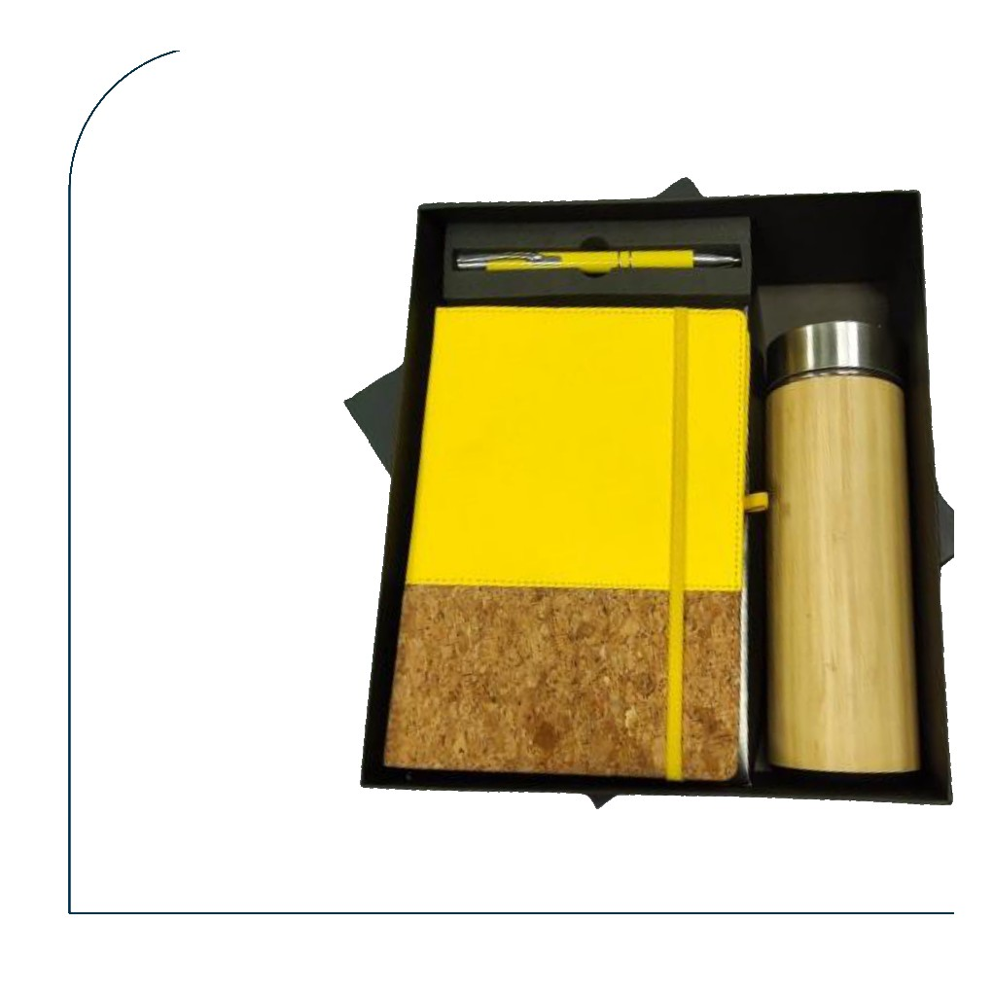  Yellow Cork Diary + Pen + Bamboo Bottle  Vibrant yellow & cork diary with matching yellow pen and bamboo thermos bottle  Rs. 555/- Base Rs. 470 + 18% GST |  | Item No. 14  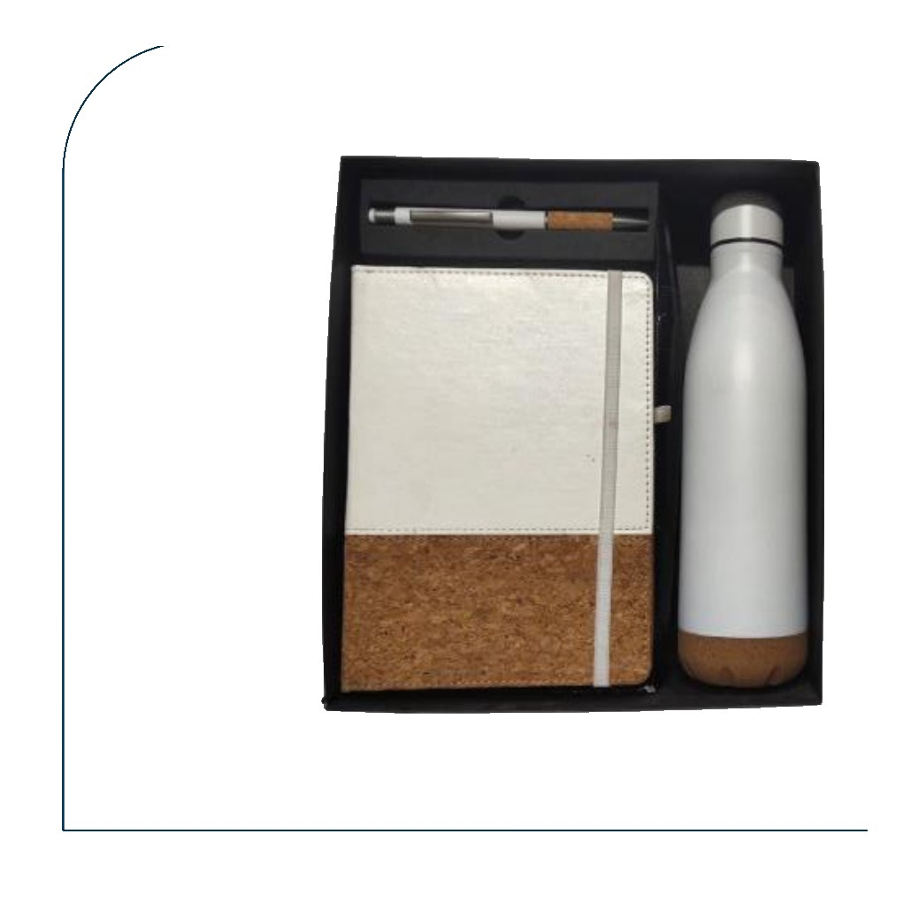  White Cork Diary + Cork Pen + Cola Bottle  White & cork diary with metal cork-grip pen and white metallic cola bottle  Rs. 561/- Base Rs. 475 + 18% GST
Item No. 15  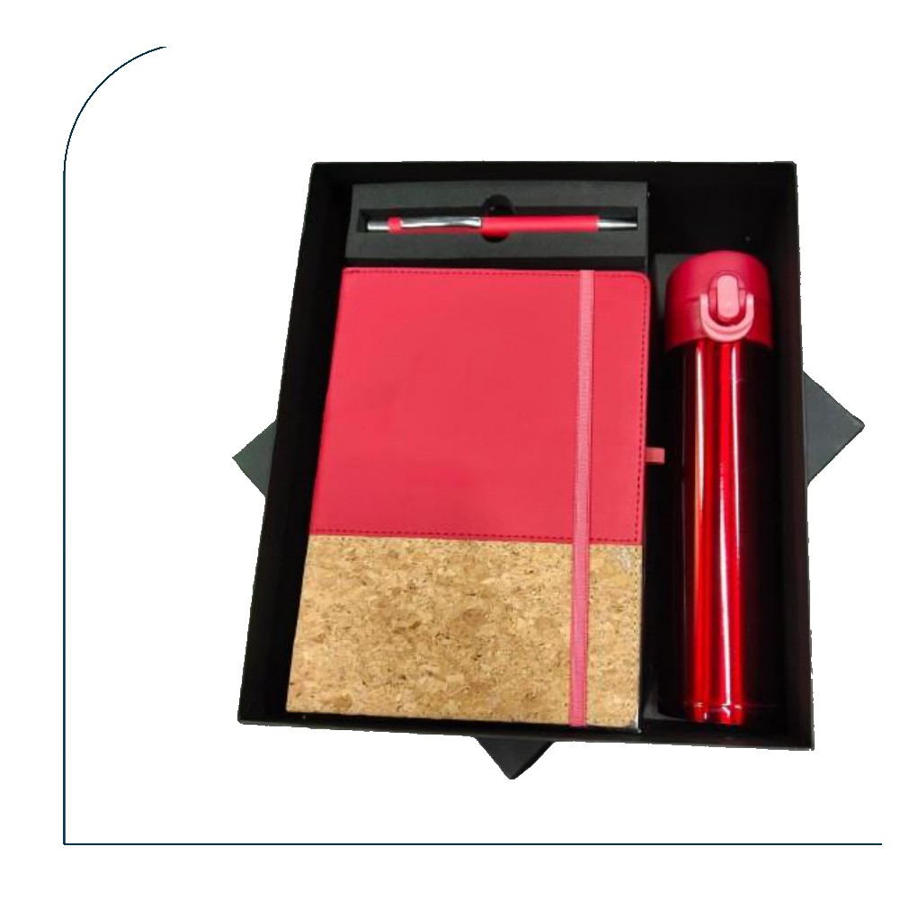  Red Cork Diary + Pen + Red Bottle  Pink-red & cork diary with matching pen and red temperature bottle  Rs. 425/- Base Rs. 360 + 18% GST |  | Item No. 16  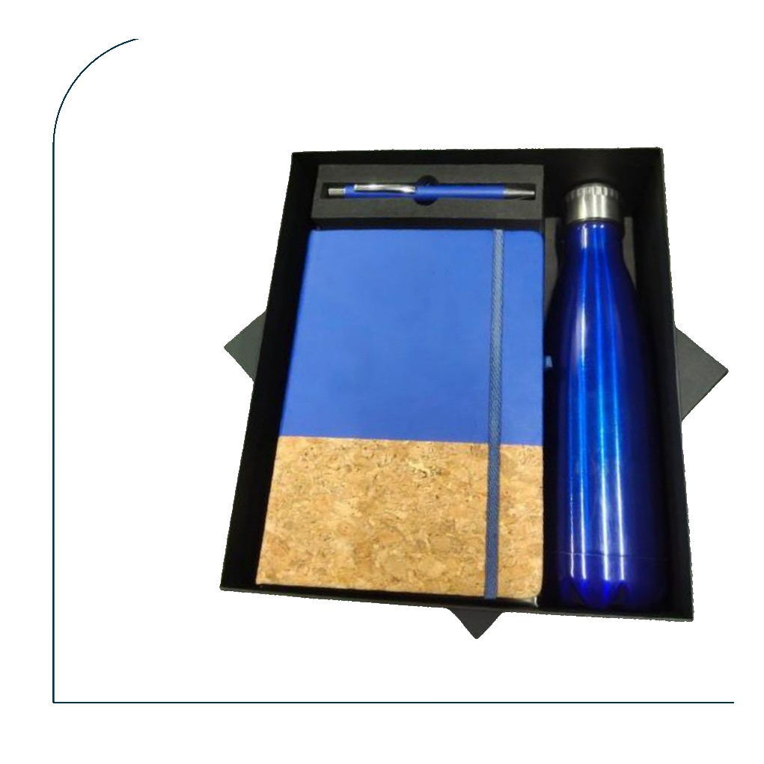  Blue Cork Diary + Pen + Blue Cola Bottle  Royal blue & cork diary with matching blue pen and blue metallic cola bottle  Rs. 413/- Base Rs. 350 + 18% GST
Item No. 17  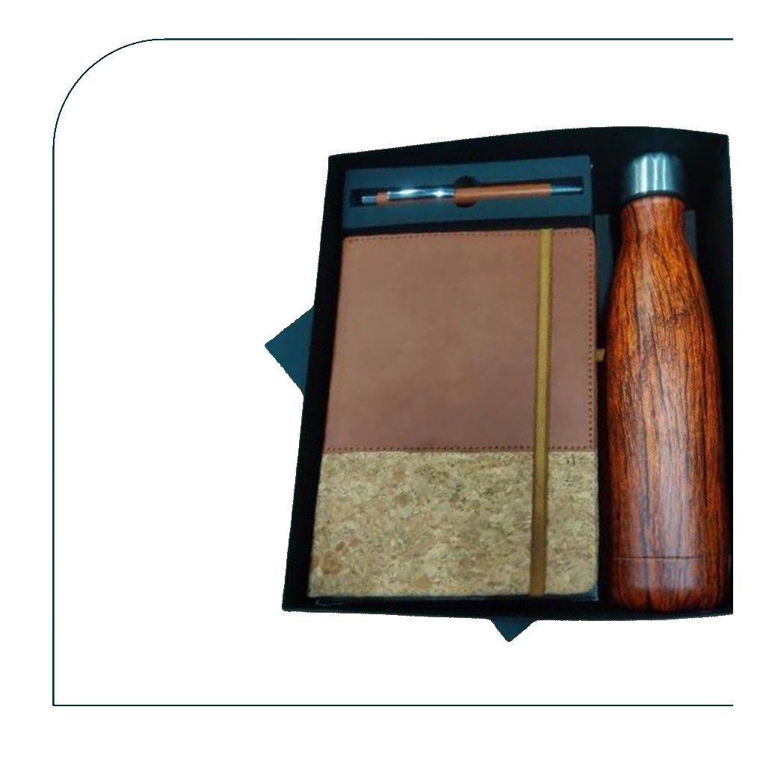  Tan Cork Diary + Pen + Wood-Grain Cola Bottle  Tan & cork diary with pen and dark wood-grain print cola bottle  Rs. 543/- Base Rs. 460 + 18% GST |  | Item No. 18  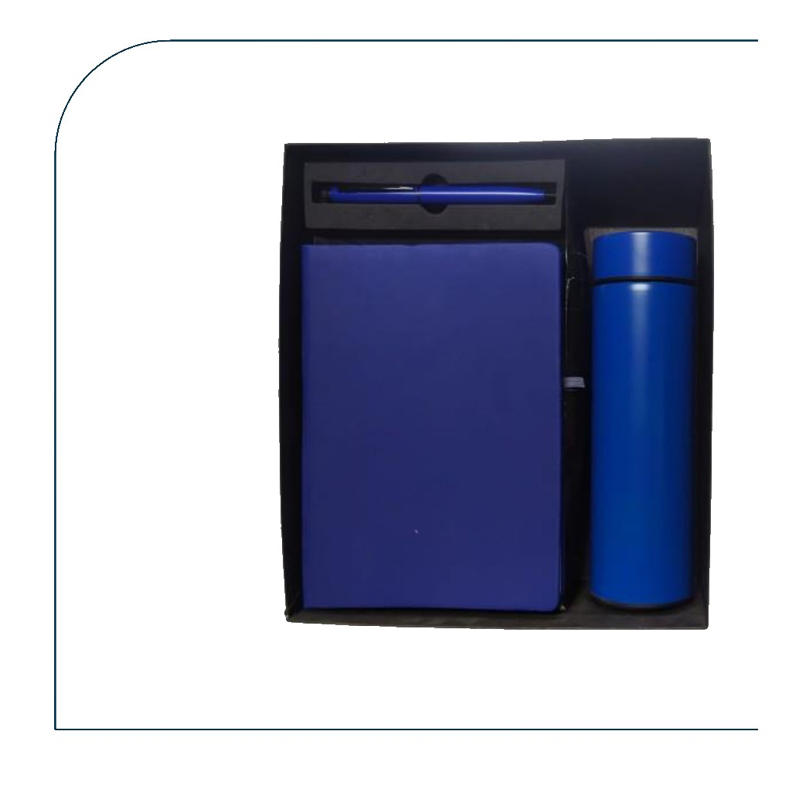  Blue Diary + Pen + Blue Temperature Bottle  Royal blue leatherette diary with matching blue pen and blue temperature bottle  Rs. 384/- Base Rs. 325 + 18% GST
Item No. 19  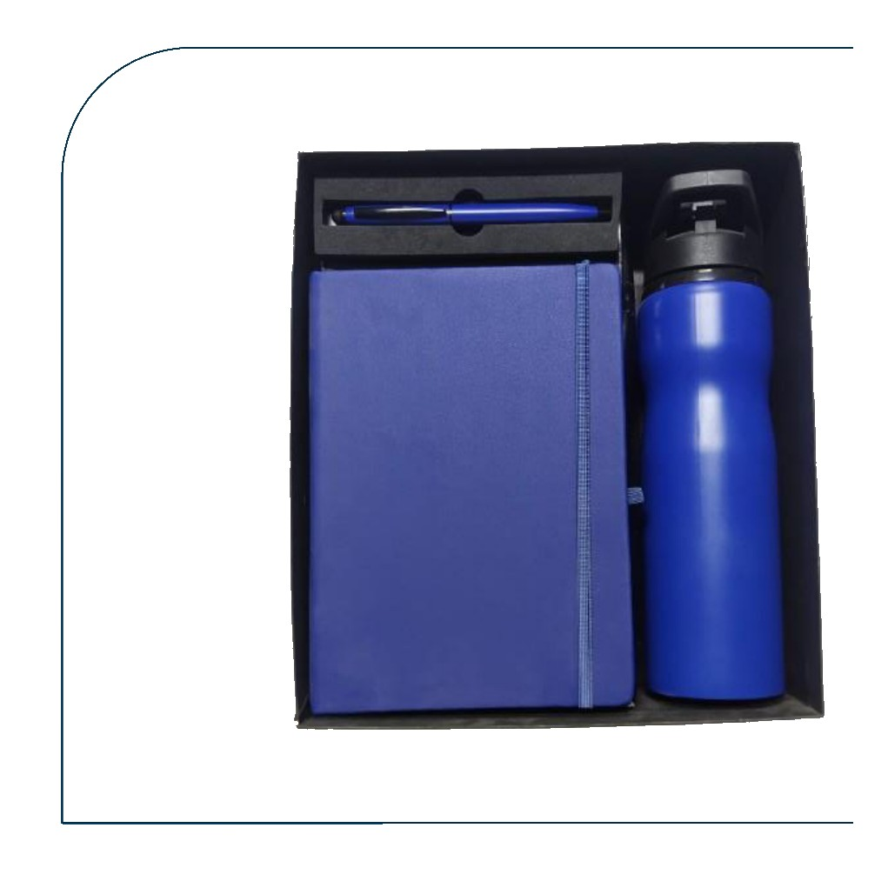  Blue Diary + Pen + Blue H2O Bottle 750 ml  Blue leatherette diary with blue pen and blue H2O sports bottle 750 ml  Rs. 354/- Base Rs. 300 + 18% GST |  | Item No. 20  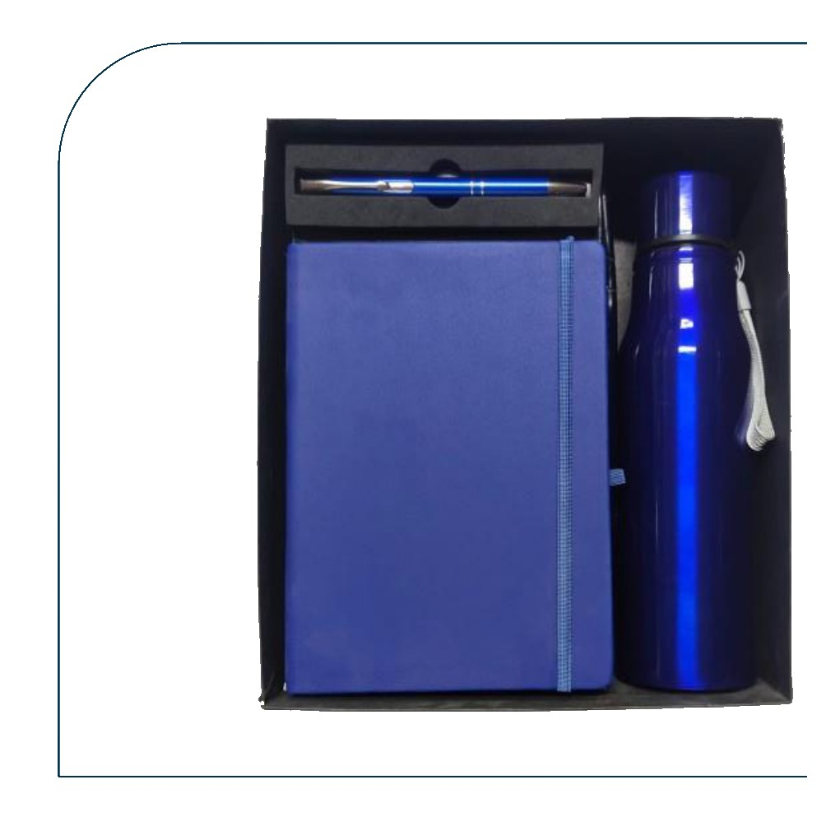  Blue Diary + Pen + Blue Metallic Bottle  Blue leatherette diary with pen and blue metallic sports bottle with rope handle  Rs. 354/- Base Rs. 300 + 18% GST
Item No. 21  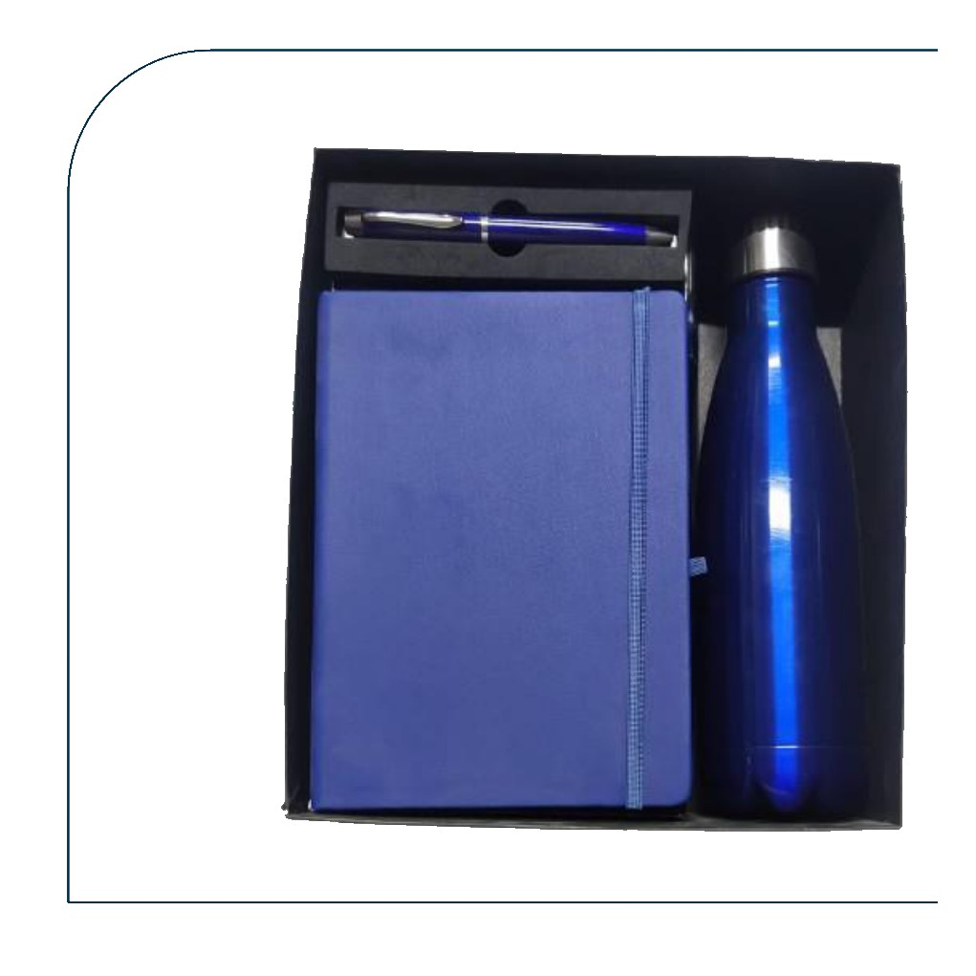  Blue Diary + Pen + Blue Cola Bottle  Blue leatherette diary with pen and blue metallic cola-shape bottle  Rs. 389/- Base Rs. 330 + 18% GST |  | Item No. 22  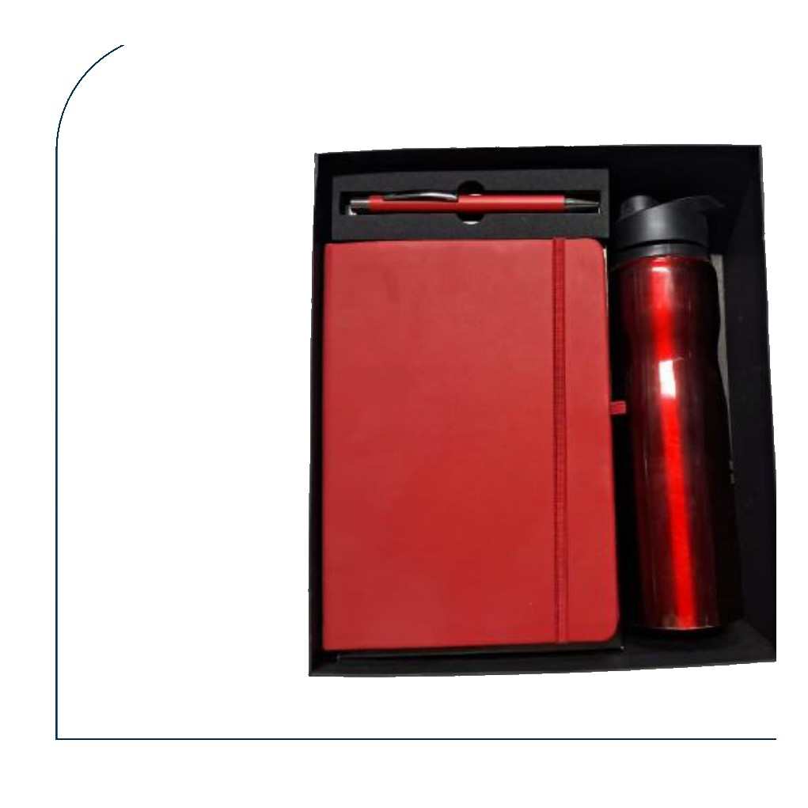  Red Diary + Pen + Red H2O Bottle 750 ml  Red leatherette diary with red pen and red H2O sports bottle 750 ml  Rs. 354/- Base Rs. 300 + 18% GST
Item No. 23  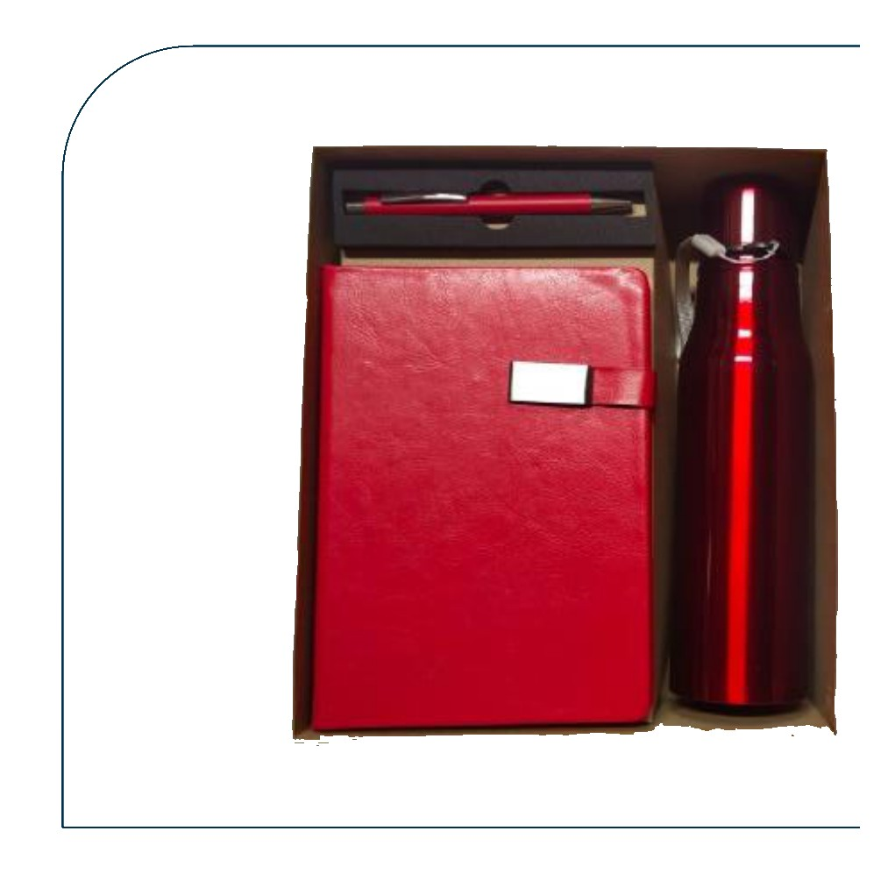  Red Diary + Pen + Red Metallic Bottle  Red leather clasp diary with red pen and deep red metallic cola bottle  Rs. 384/- Base Rs. 325 + 18% GST |  | Item No. 24  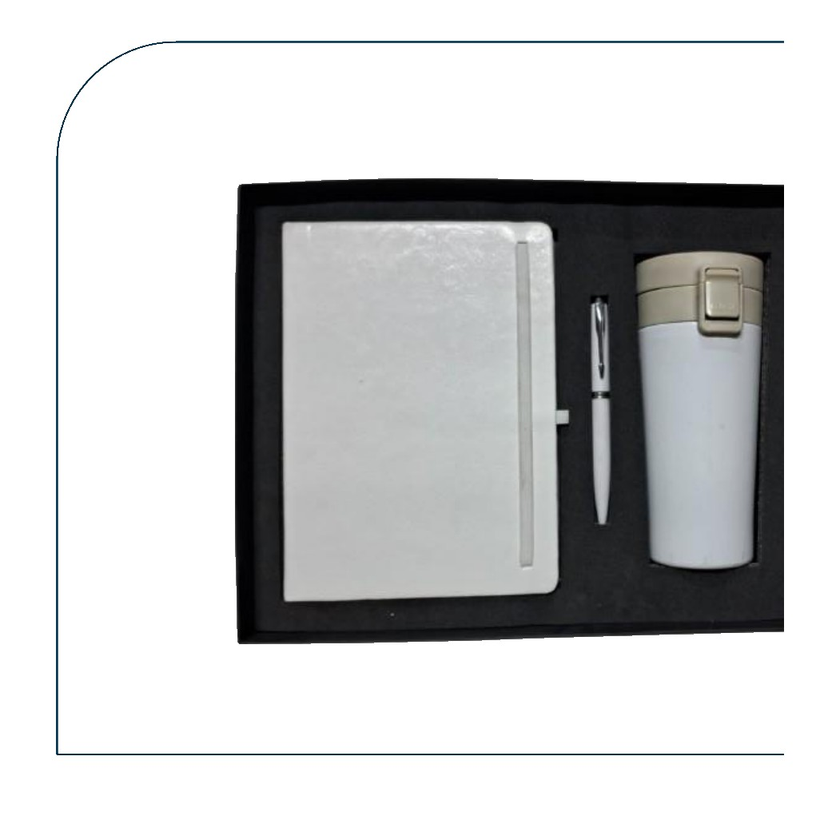  White Diary + Pen + White Travel Mug  White leatherette diary with white pen and white double-walled travel mug with clip lid  Rs. 561/- Base Rs. 475 + 18% GST
Item No. 25  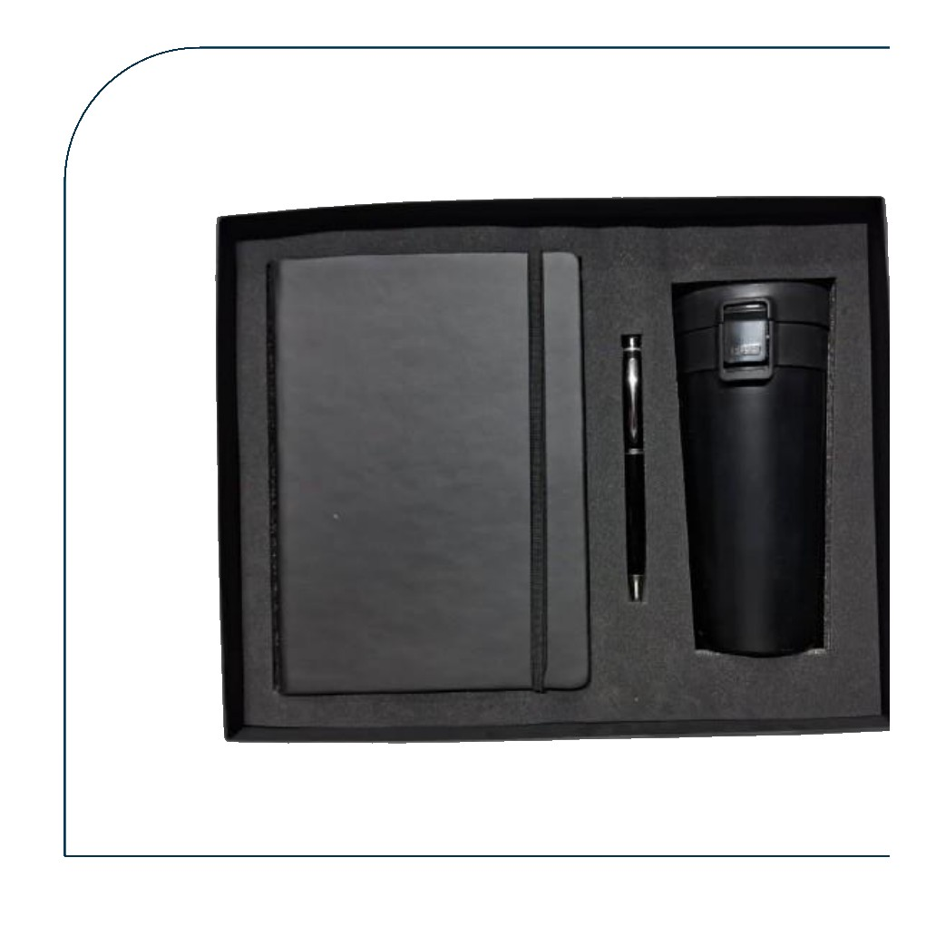  Black Diary + Pen + Black Travel Mug  Black leatherette diary with black pen and matte black double-walled travel mug  Rs. 561/- Base Rs. 475 + 18% GST |  | Item No. 26  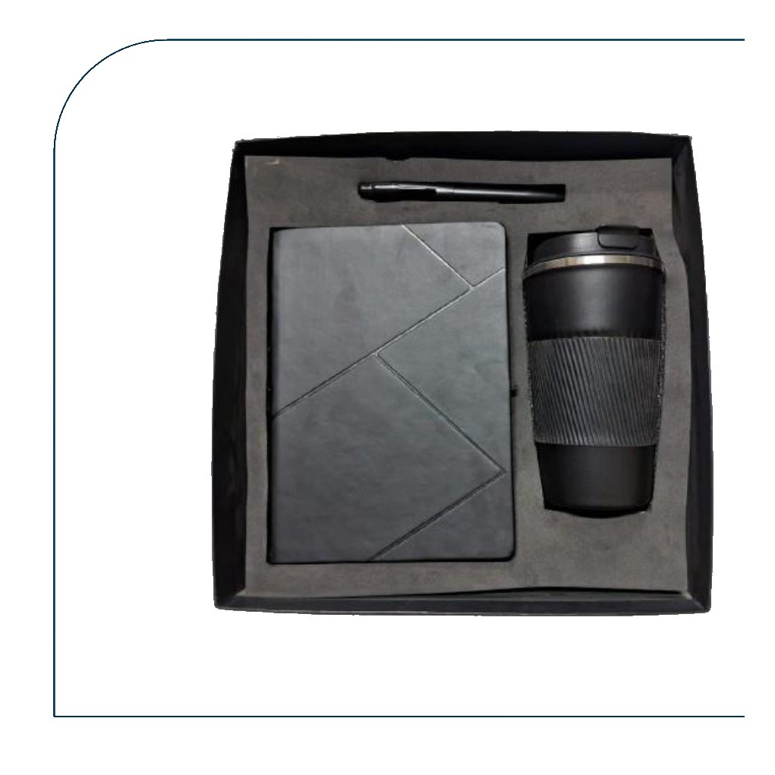  Grey Suede Diary + Pen + Black Mug  Grey suede triangle-cut diary with pen and matte black ribbed travel mug  Rs. 620/- Base Rs. 525 + 18% GST
Item No. 27  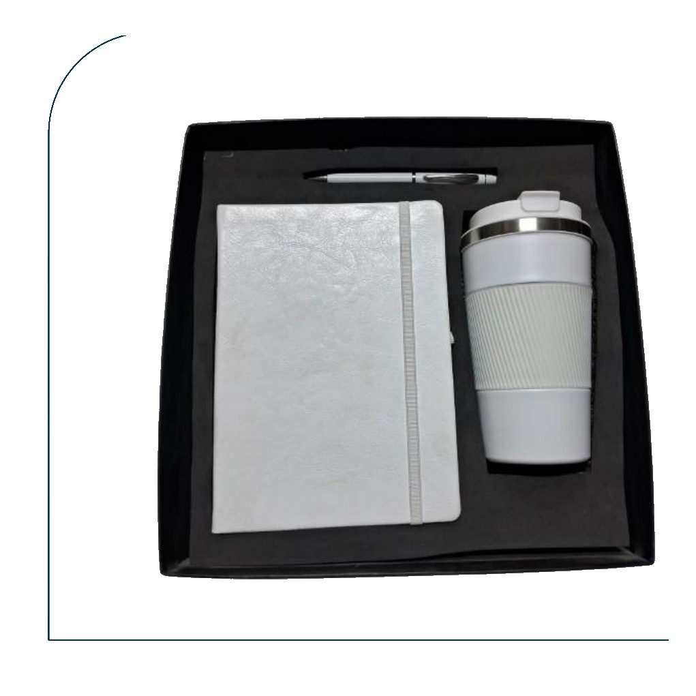  White Diary + Pen + White Ribbed Mug  White leatherette diary with pen and white double-walled ribbed travel mug with steel lid  Rs. 620/- Base Rs. 525 + 18% GST |  | Item No. 28  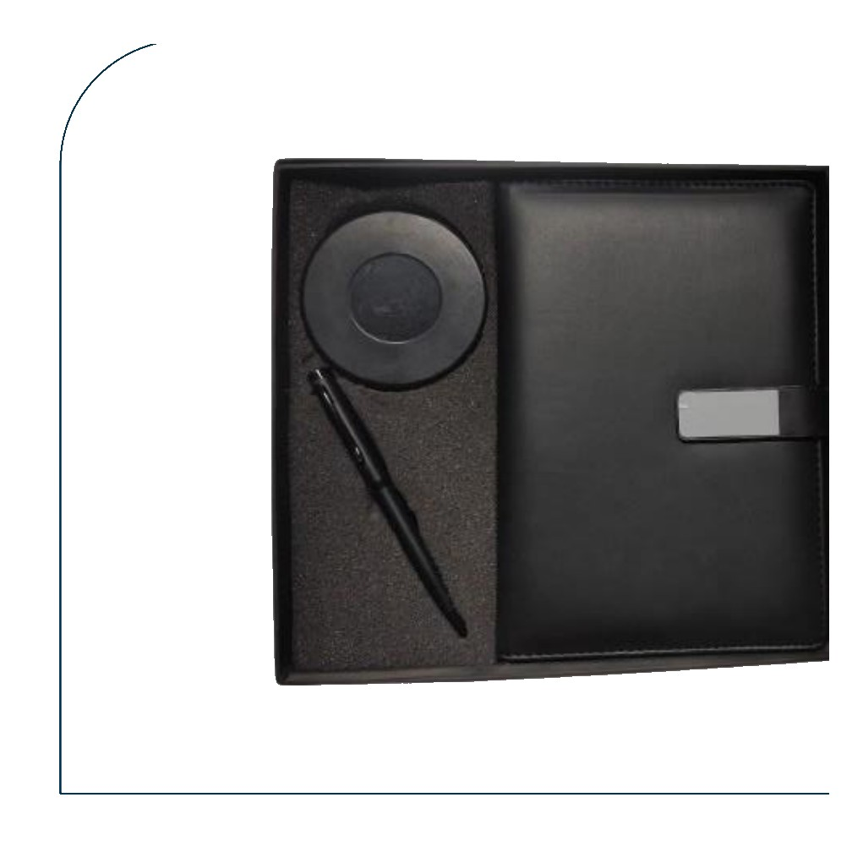  Black Diary + Pen + Wireless Charging Pad  Black leather clasp diary with pen and round matte black wireless charging pad  Rs. 384/- Base Rs. 325 + 18% GST
Item No. 29  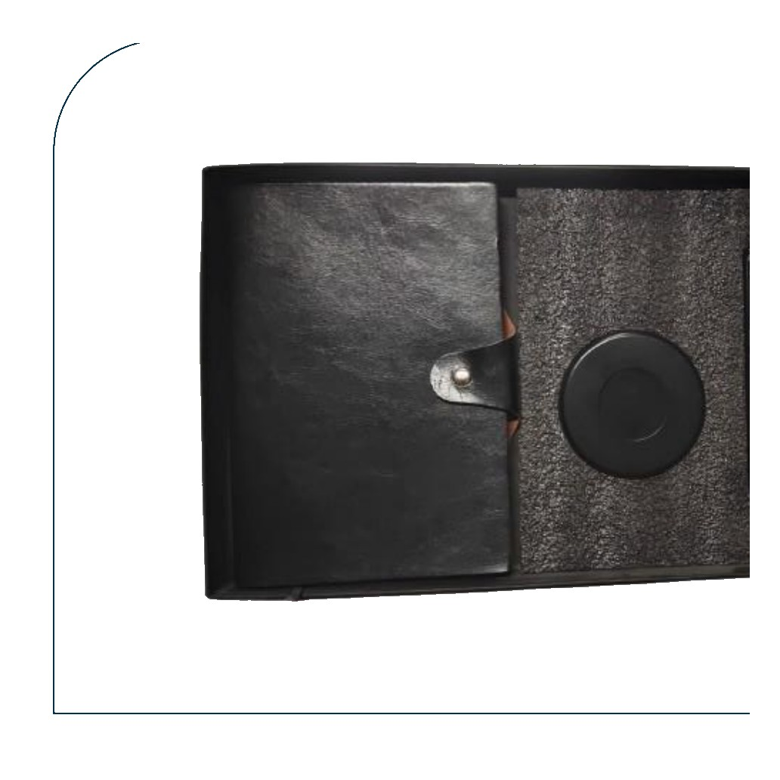  Black Diary + Pen + Wireless Charging Pad  Black distressed leather diary with pen and compact wireless charging pad  Rs. 354/- Base Rs. 300 + 18% GST |  | Item No. 30  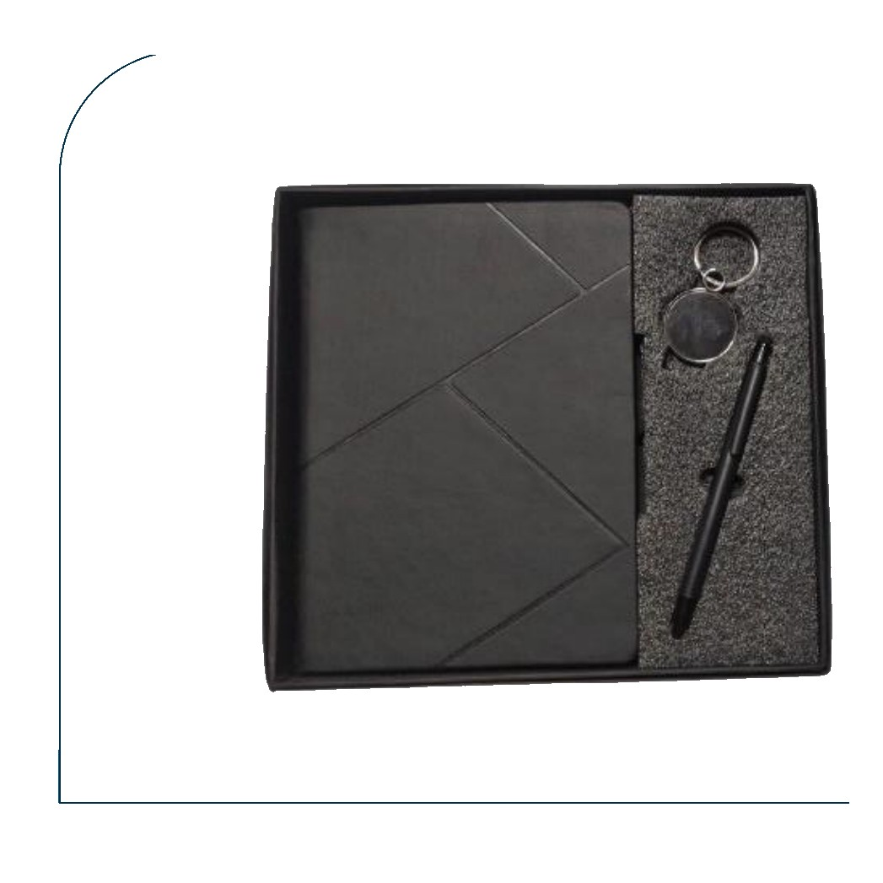  Grey Suede Diary + Pen + Round Keychain  Dark grey suede diary with black pen and round mirror-finish metal keychain  Rs. 277/- Base Rs. 235 + 18% GST
Item No. 31  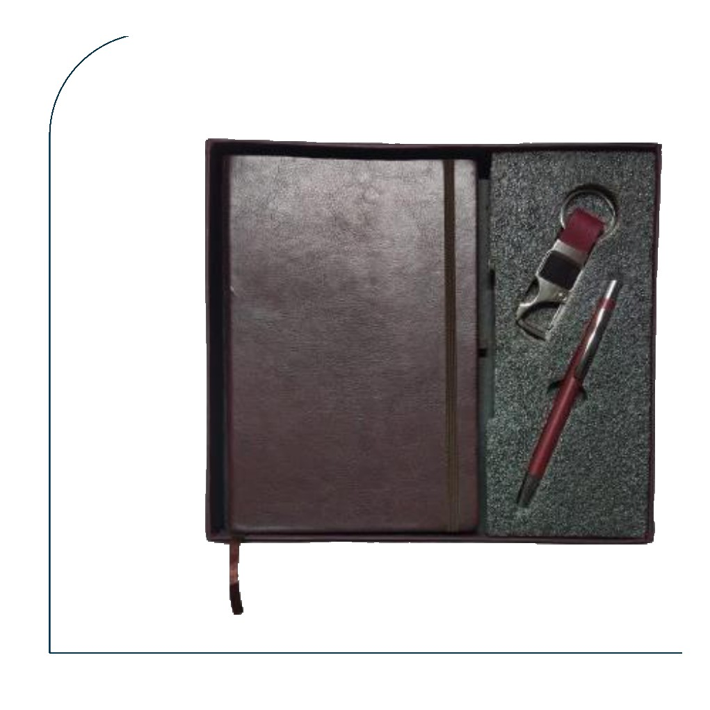  Brown Leather Diary + Pen + Keychain  Dark brown leather diary with maroon pen and maroon leather-strap metal keychain  Rs. 248/- Base Rs. 210 + 18% GST |  | Item No. 32  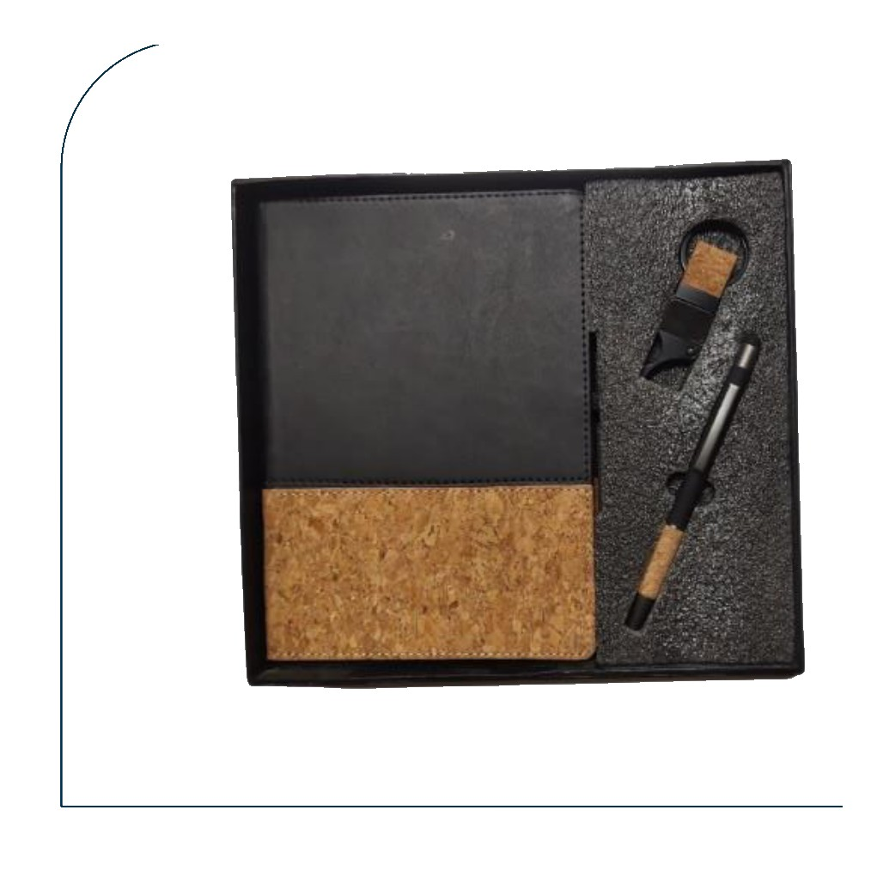  Cork Diary + Cork Pen + Cork Keychain  All-cork eco set — black & cork diary with cork pen and cork-faced square keychain  Rs. 295/- Base Rs. 250 + 18% GST
Item No. 33  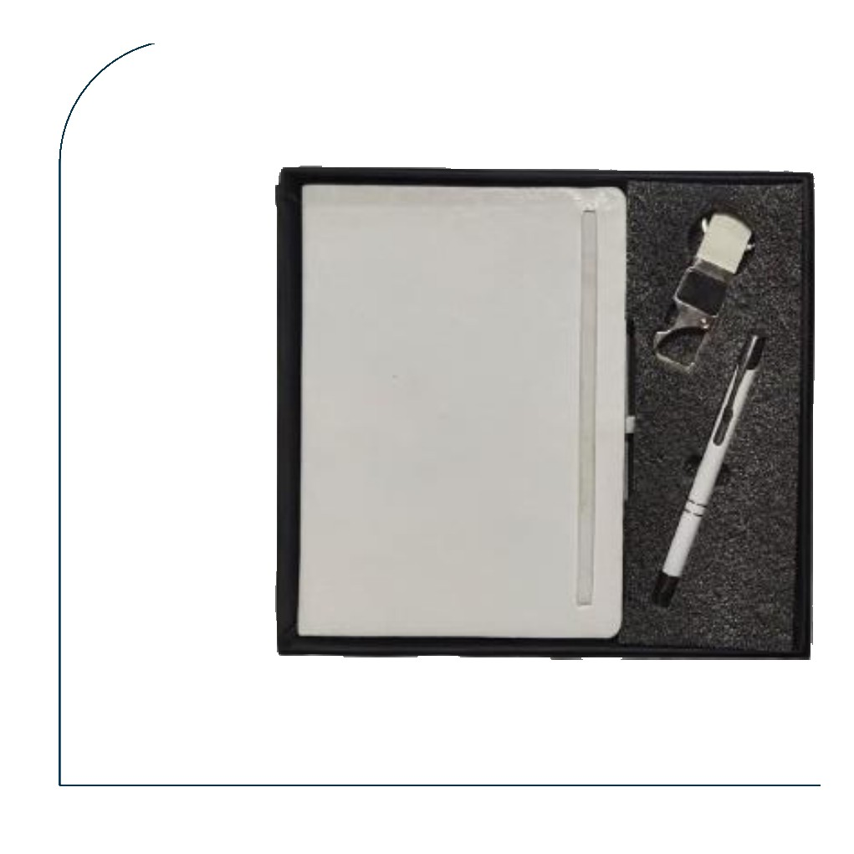  White Diary + Pen + Silver Keychain  White soft leatherette diary with white pen and silver metal tag keychain  Rs. 248/- Base Rs. 210 + 18% GST |  | Item No. 34  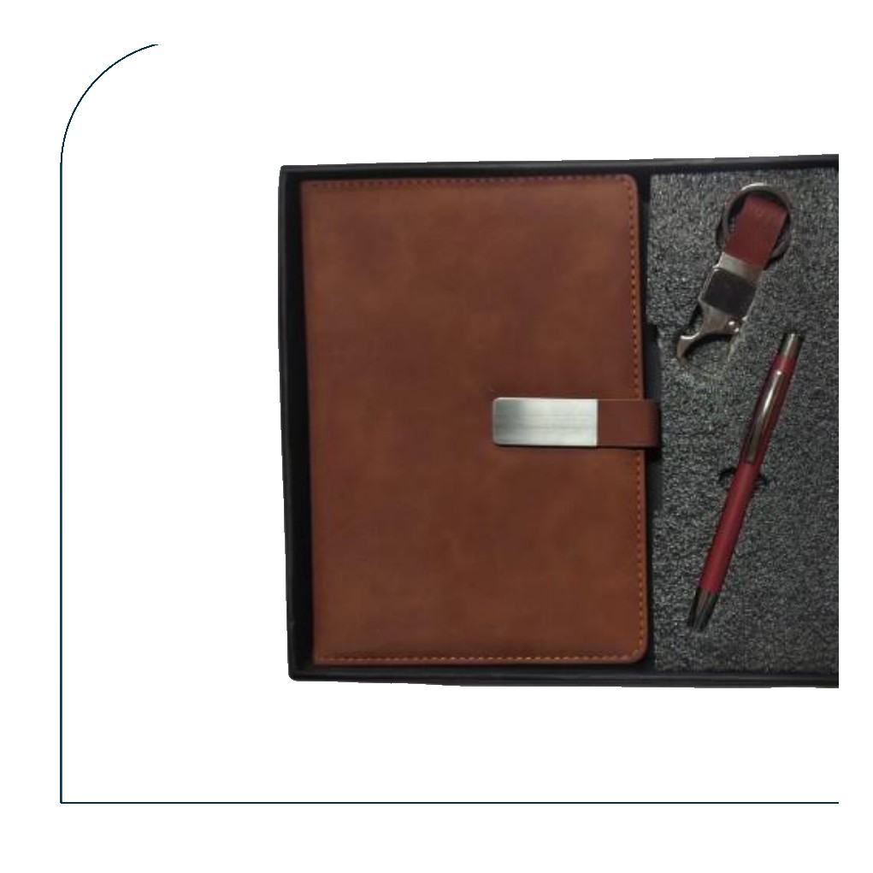  Tan Diary + Pen + Tan Leather Keychain  Tan nubuck diary with maroon pen and tan leather lobster-claw keychain  Rs. 307/- Base Rs. 260 + 18% GST
Item No. 35  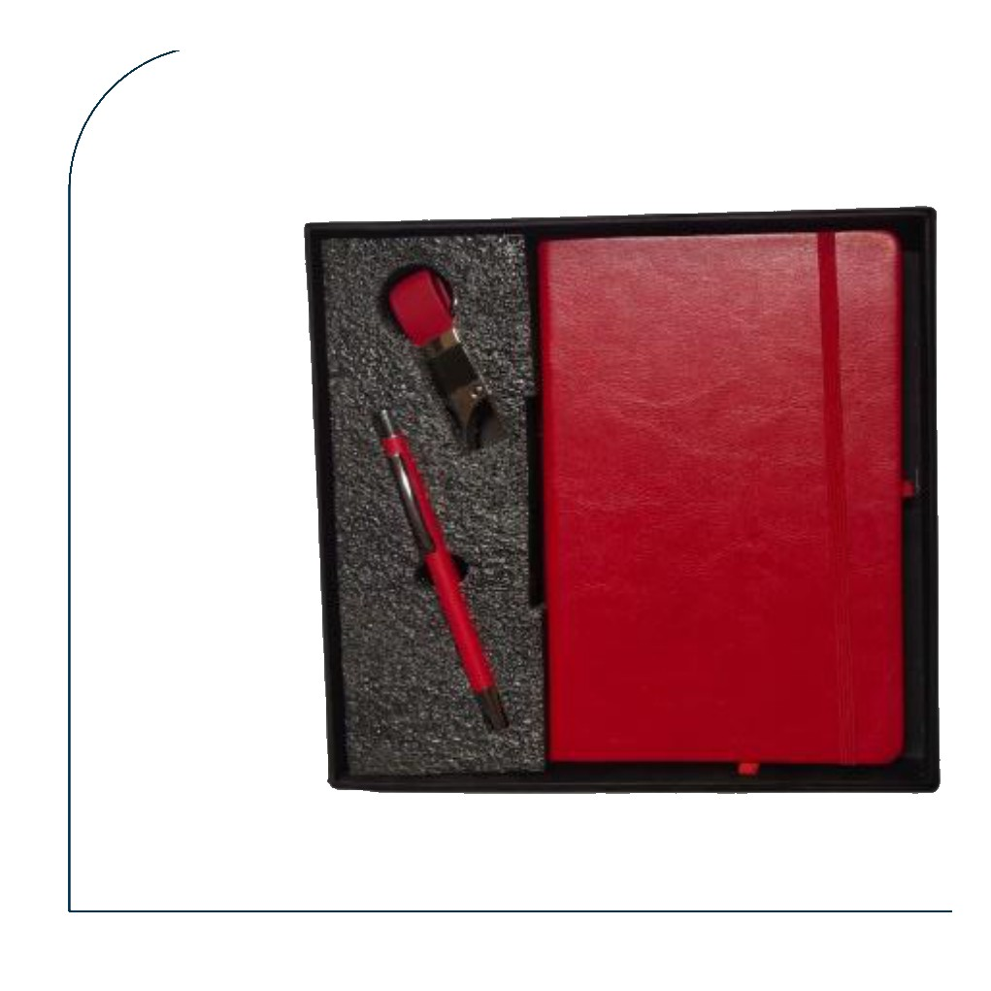  Red Diary + Pen + Red Keychain  Red leatherette diary with red pen and red leather-strap metal keychain  Rs. 266/- Base Rs. 225 + 18% GST |  | Item No. 36  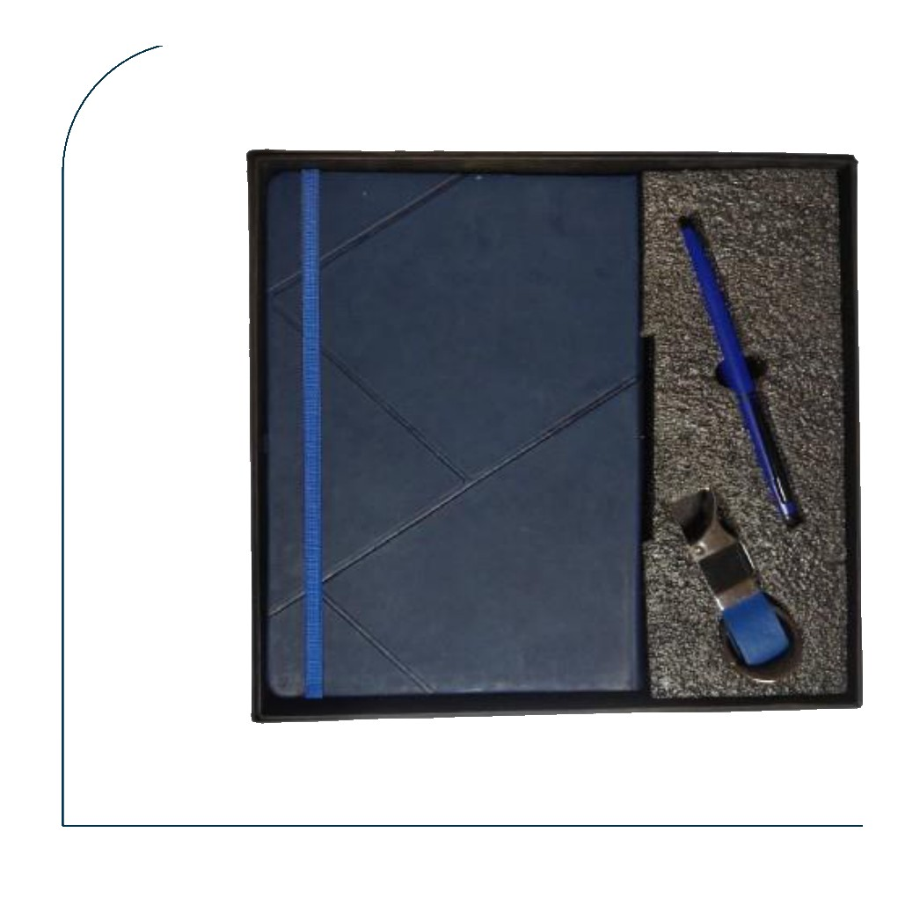  Blue Diary + Pen + Blue Keychain  Navy blue diary with blue pen and blue metal square keychain  Rs. 295/- Base Rs. 250 + 18% GST
Item No. 37  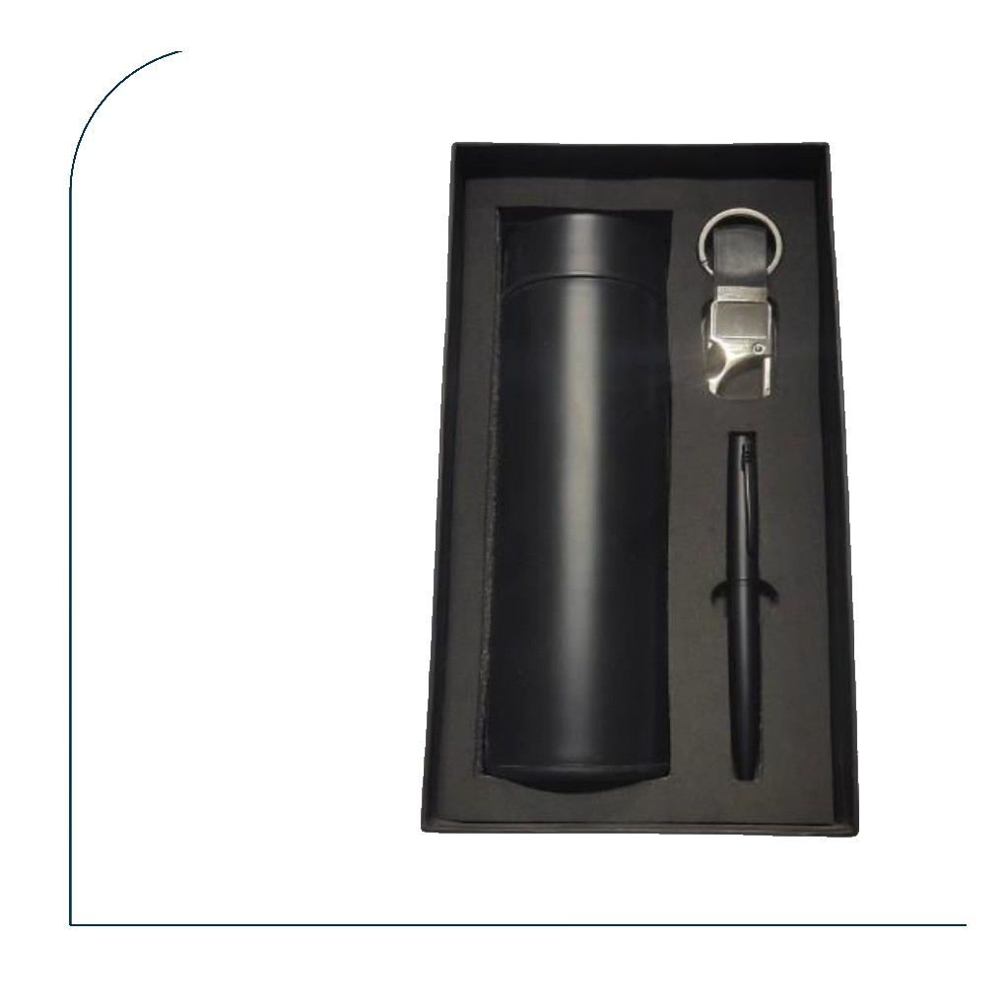  Black Bottle + Pen + Metal Keychain  Matte black temperature bottle with black pen and silver metal-ring keychain  Rs. 354/- Base Rs. 300 + 18% GST |  | Item No. 38  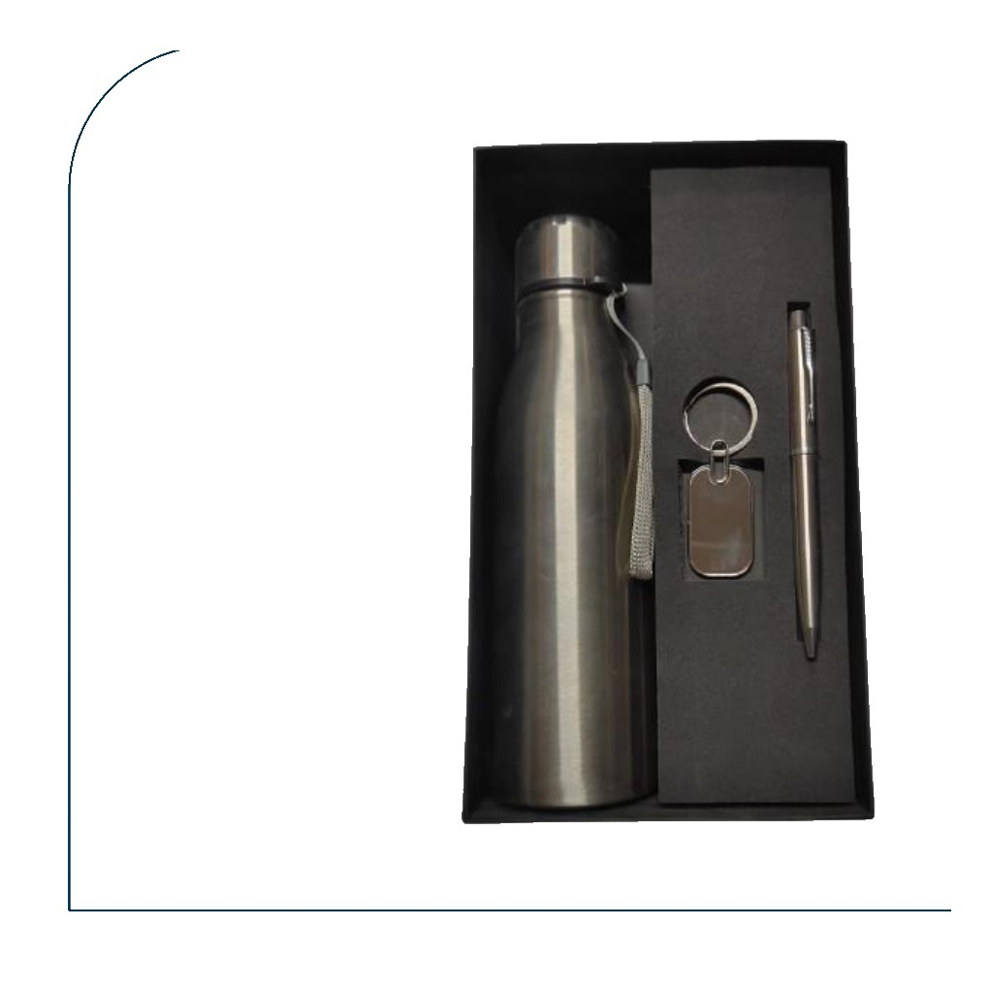  Silver Bottle + Pen + Tag Keychain  Silver stainless steel cola bottle with silver pen and rectangular silver tag keychain  Rs. 325/- Base Rs. 275 + 18% GST
Item No. 39  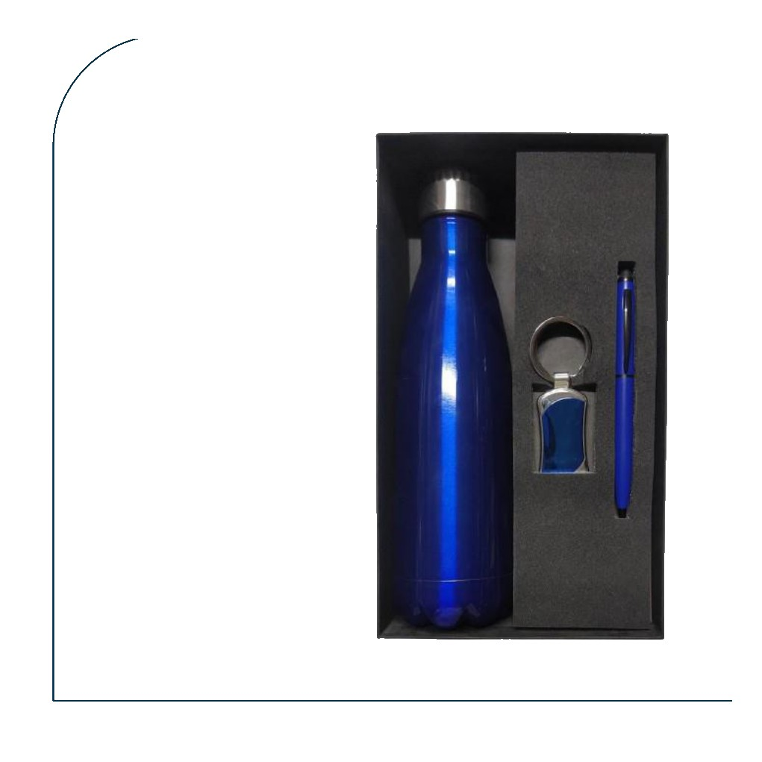  Blue Cola Bottle + Pen + Blue Keychain  Metallic blue cola bottle with blue pen and blue-insert metal keychain  Rs. 354/- Base Rs. 300 + 18% GST |  | Item No. 40  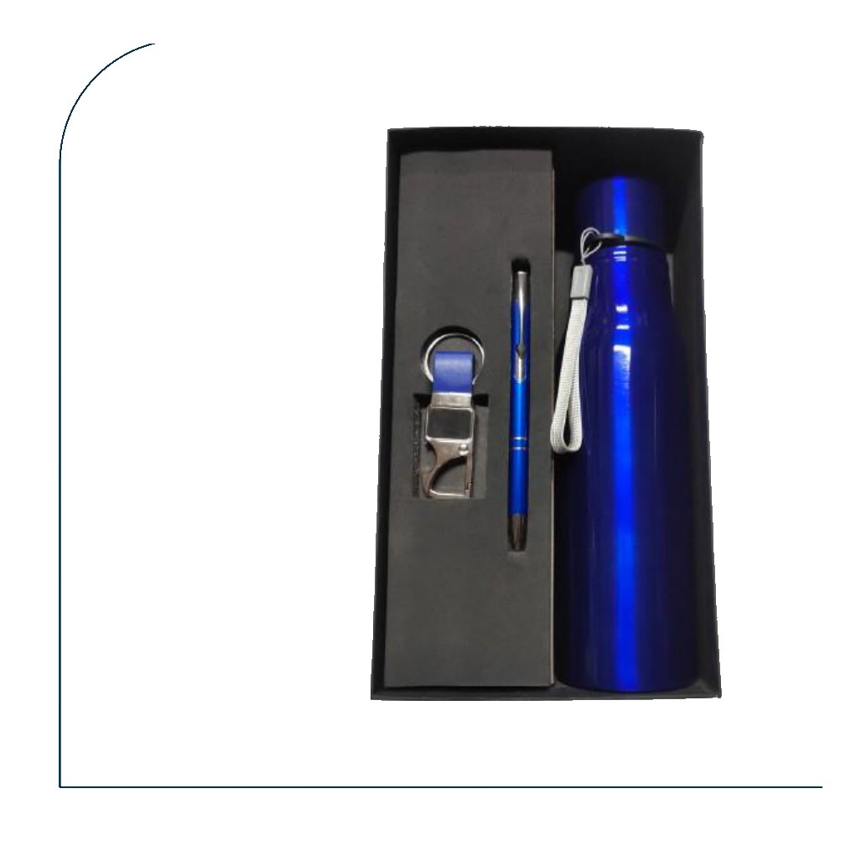  Blue Bottle + Pen + Blue Keychain  Metallic blue sports bottle with blue pen and blue leather-strap keychain  Rs. 325/- Base Rs. 275 + 18% GST
Item No. 41  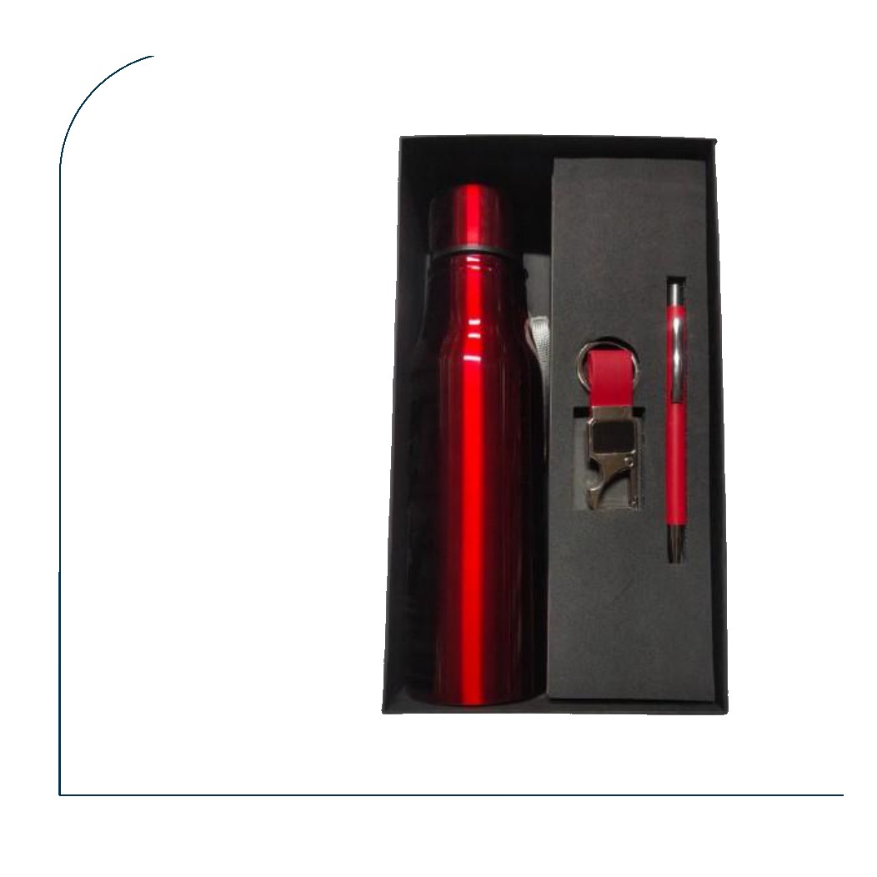  Red Bottle + Pen + Red Keychain  Metallic red cola bottle with red pen and red leather-strap metal keychain  Rs. 325/- Base Rs. 275 + 18% GST |  | Item No. 42  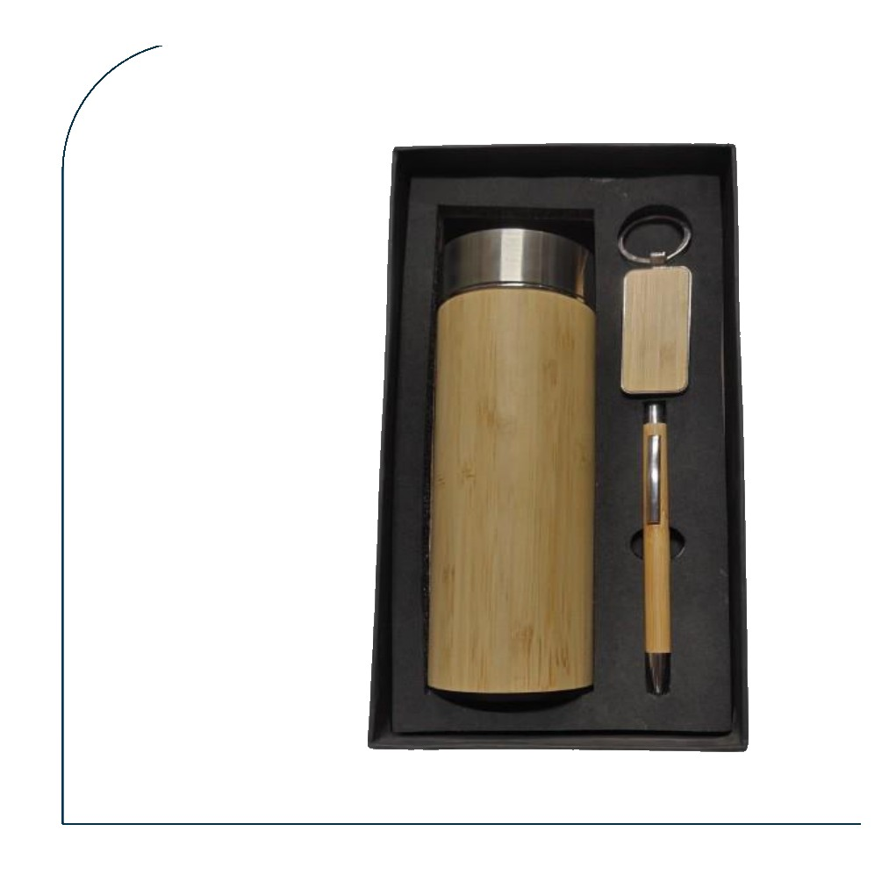  Bamboo Bottle + Bamboo Pen + Bamboo Keychain  All-bamboo eco set — bamboo thermos bottle with bamboo pen and bamboo rectangular keychain  Rs. 472/- Base Rs. 400 + 18% GST
Item No. 43  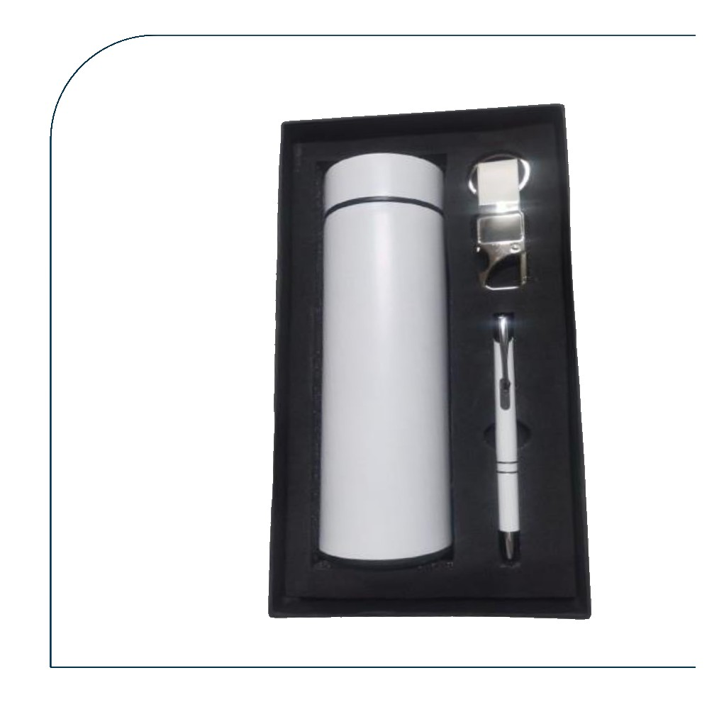  White Bottle + Pen + Metal Keychain  White temperature bottle with white pen and silver metal-ring keychain  Rs. 325/- Base Rs. 275 + 18% GST |  | Item No. 44  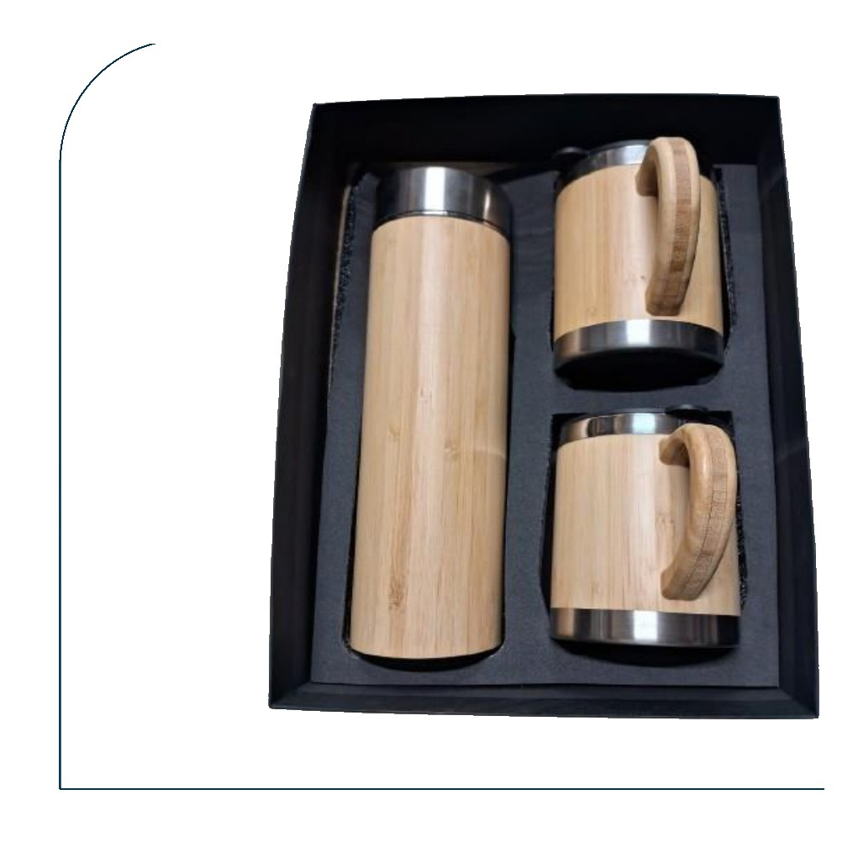  Bamboo Bottle + 2 Bamboo Mugs  Large bamboo thermos bottle paired with two bamboo-wrapped steel mugs with handles  Rs. 974/- Base Rs. 825 + 18% GST
Item No. 45  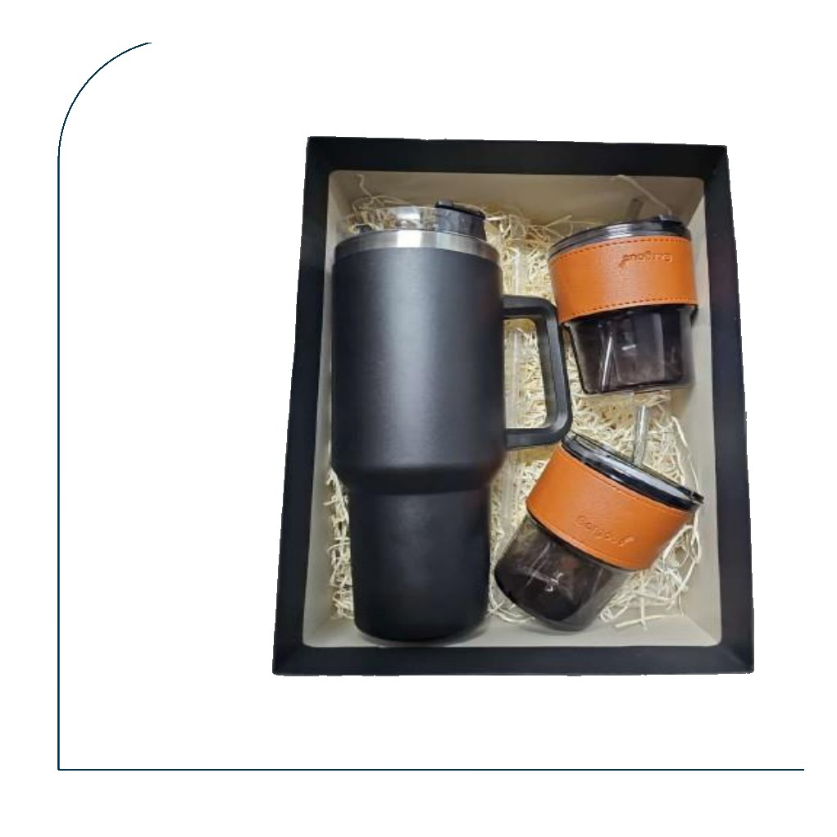  Tumbler + 2 Glass Mugs (Leather Sleeve)  Matte black Stanley-style tumbler with two glass mugs wrapped in tan leather sleeves  Rs. 590/- Base Rs. 500 + 18% GST |  | Item No. 46  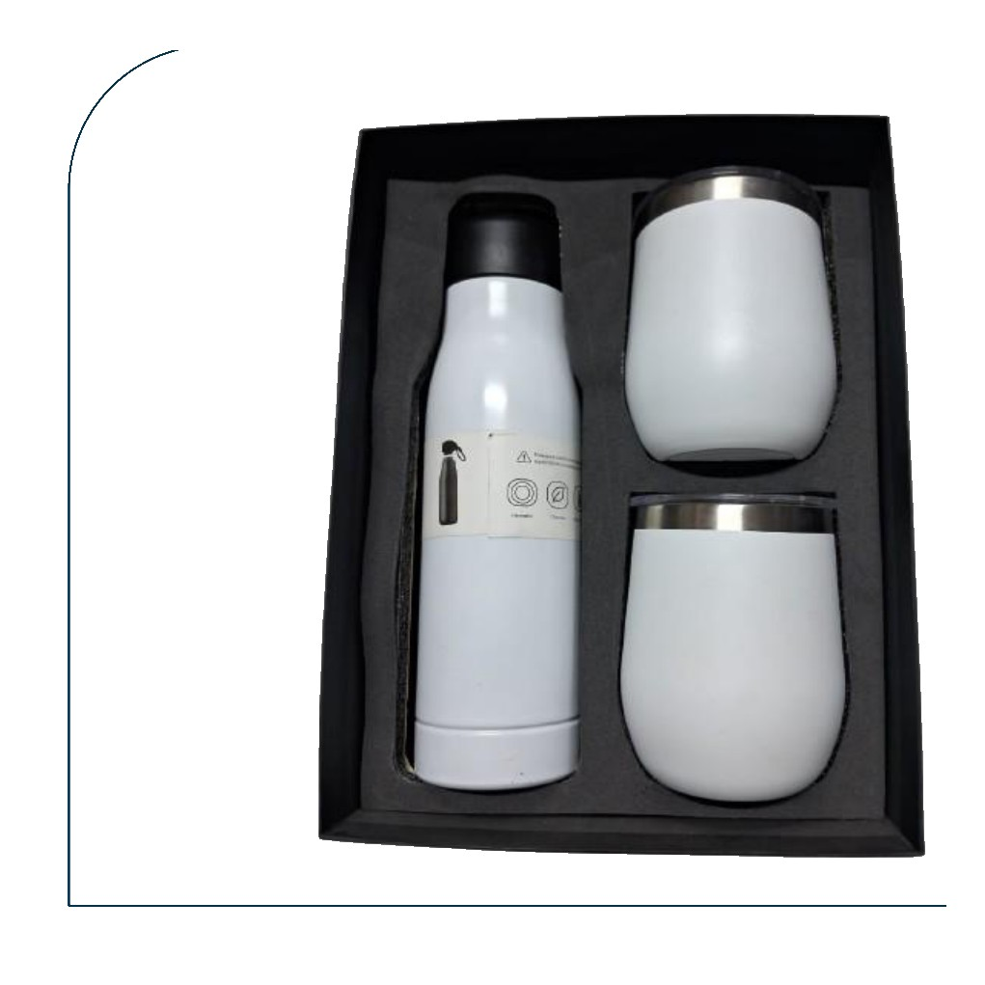  White Cola Bottle + 2 Stemless Mugs  White cola bottle paired with two white double-walled stemless steel mugs  Rs. 649/- Base Rs. 550 + 18% GST
Item No. 47  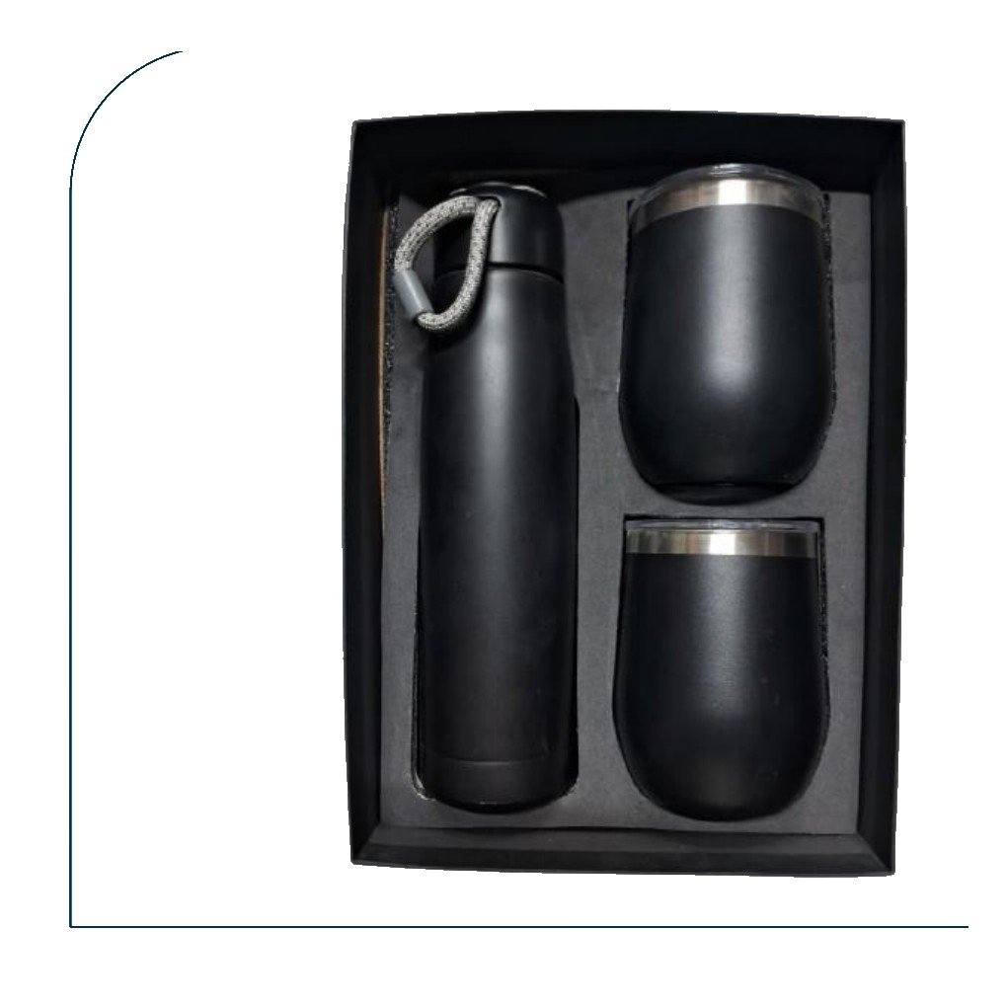  Black Rope Bottle + 2 Black Stemless Mugs  Black bottle with rope handle paired with two matte black double-walled stemless mugs  Rs. 649/- Base Rs. 550 + 18% GST |  | Item No. 48  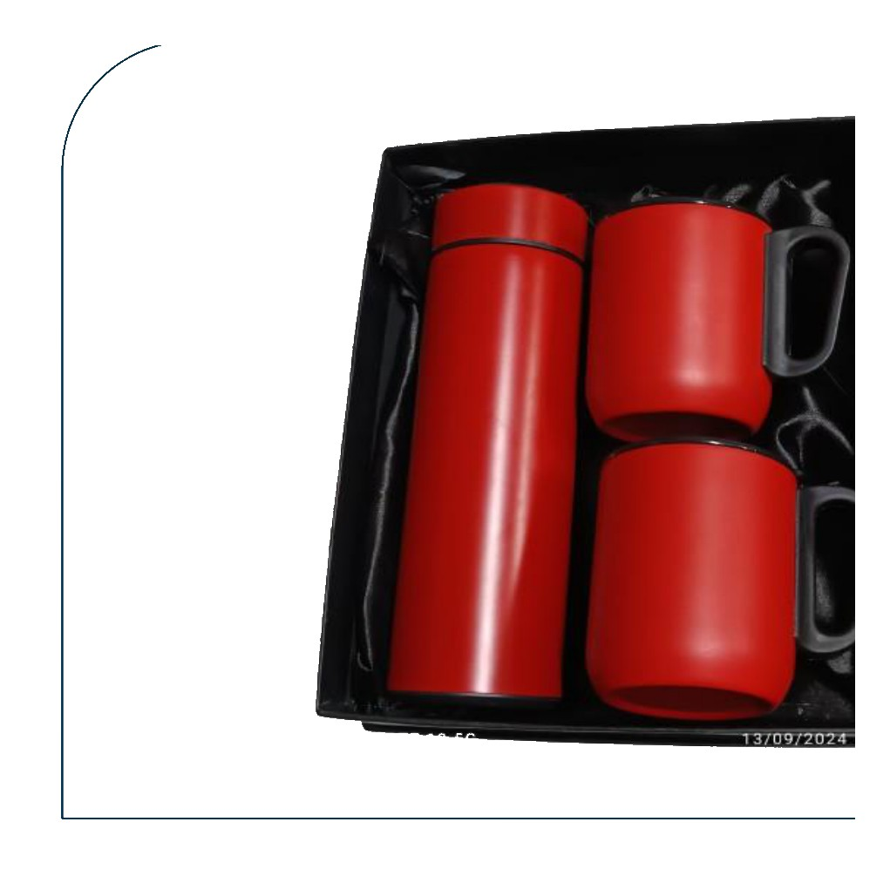  Red Bottle + 2 Red Steel Mugs  Red temperature bottle paired with two red stainless steel handled mugs  Rs. 531/- Base Rs. 450 + 18% GST
Item No. 49  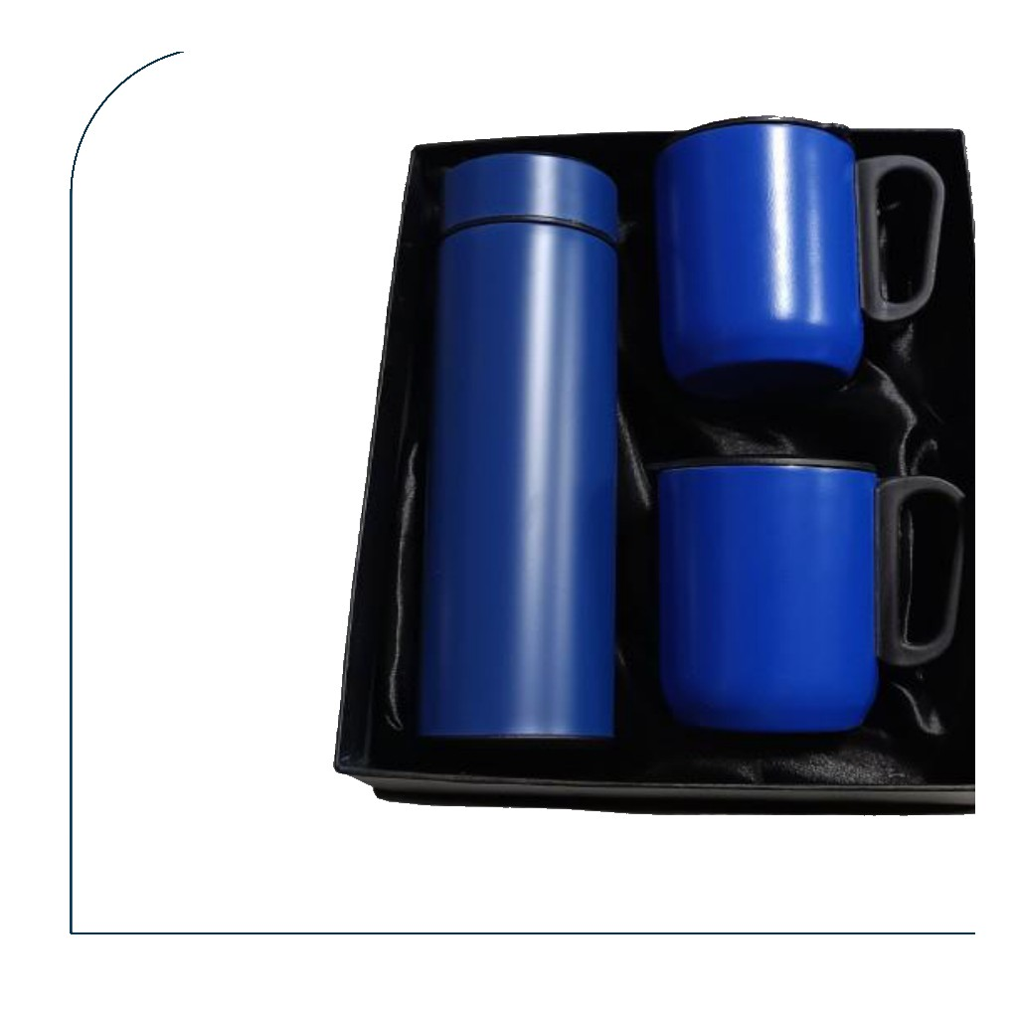  Blue Bottle + 2 Blue Steel Mugs  Blue temperature bottle paired with two blue stainless steel handled mugs  Rs. 531/- Base Rs. 450 + 18% GST |  | Item No. 50  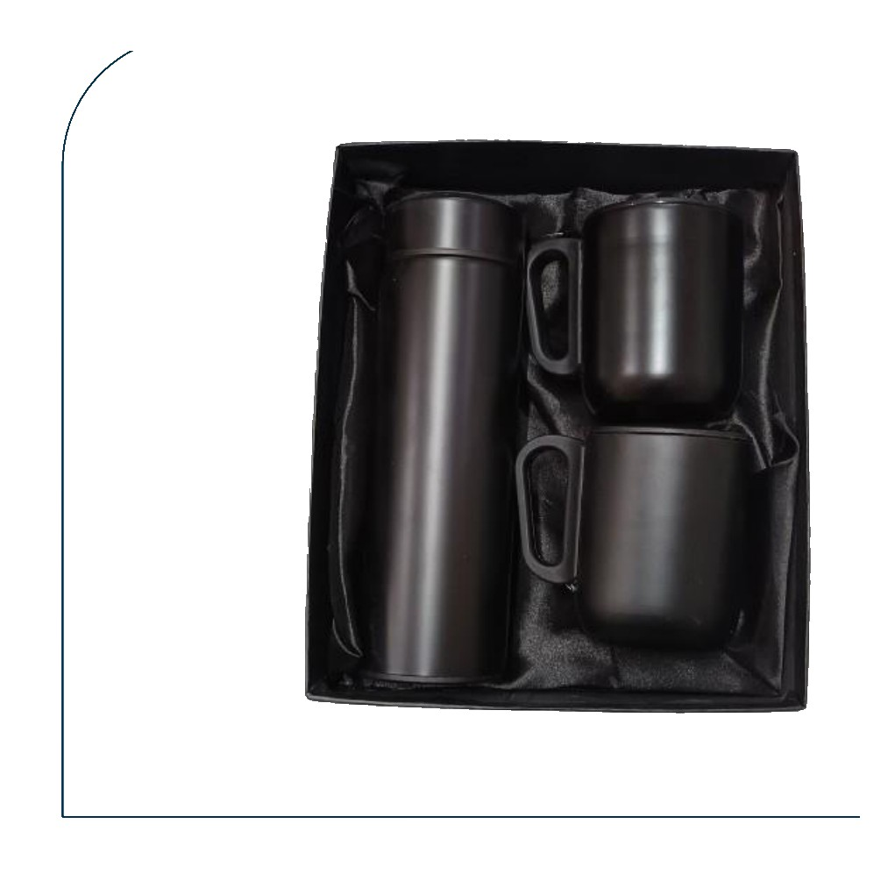  Gunmetal Bottle + 2 Dark Steel Mugs  Gunmetal temperature bottle paired with two matte dark stainless steel handled mugs  Rs. 531/- Base Rs. 450 + 18% GST

